J

Business Requirements Document

  - CCH Tagetik – Budget, Planning, and Forecasting + Consolidation



Version 2.0
Release date: TBD, 2025

CONFIDENTIAL FOR INTERNAL USE ONLY

Document Change Control
Version | Author | Status | Description | Release  Date
1.0 | Jeffrey Page | Draft | Initial draft | 2025/08/19
1.0 | RCGT / AKC team | Updates |  | 2025/09/  26-29
1.0 |  | Updates |  | TBD
1.0 | Jeffrey Page | 1st Release | Initial Release to Boralex | 2025/09/30
1.1 | Jeffrey Page | Updates | Updates after walkthrough with Boralex | TBD
2.0 | Jeffrey Page | 2nd Release | 2nd Release to client | TBD
2.1 | Jeffrey Page | Updates | Updates after 2nd walkthrough with Boralex | TBD
3.0 | Jeffrey Page | Updates | Final draft released to Boralex for sign-off | TBD
 | Julien Schrapp | Phase 0 | I&T sign-off for Phase 0 | 2025/10/16
 | Elliot Delage Bienvenu | Phase 0 | Business sign-off for Phase 0 | 2025/10/16

Table of Contents
1 Document Change Control 3
2 Glossary 7
3 Bookmarks 9
4 Purpose of this Document 10
5 Disclaimer 11
6 Project Specifics 12
6.1 About Boralex Inc. 12
6.2 Project Scope and Approach 12
6.3 Project Teams 12
7 Business Landscape and Current Process 14
8 Technical Landscape 15
8.1 Source Data from SAP 16
8.2 Source Data from Longview 17
8.3 Tagetik Application Components and Specifics 17
9 Tagetik Dimensionality 18
10 Configuration of Standard Dimensions 19
10.1 Scenario 19
10.2 Periods 21
10.3 Currency 22
10.4 Categories 22
10.5 GL Accounts 23
10.6 Variations 25
10.7 Control Groups 25
10.8 Entity – (Division) 25
11 Configuration of Custom Dimensions 27
11.1 Custom Dimension 1 – Cost Object 27
11.2 Custom Dimension 2 – TBD 27
11.3 Custom Dimension 3 – TBD 27
11.4 Custom Dimension 4 – TBD 27
11.5 Custom Dimension 5 – Other 27
12 Configuration of AIH Dimensions and Datasets 28
12.1 AIH Dimensions 28
12.2 AIH Workspaces and Datasets 30
13 Tagetik System Processes 32
13.1 Standard Consolidation Rules 32
13.2 Consolidation Area’s (Data Processes) 32
13.3 Actual Process 33
13.4 Planning Processes and Modules 34
13.5 Workflow 55
13.6 Ownership Structure Register 57
13.7 Basic Consolidation Configurations 57
13.8 Equity Pickup 58
13.9 Proportional Consolidation 59
13.10 Carry forward logic 60
13.11 Diagnostic 61
14 KPI’s and Custom Calculations Logic 62
15 Historical Data and Journal Entries 63
16 Data Integration Requirements/Data Sources Overview 65
17 Reporting 66
17.1 Financial Statements Templates (FST’s) 66
17.2 Reports 66
18 Security and Auditability 67
18.1 Application Security 67
18.2 Audit 68
19 Open points 69
20 Requirements Traceability Matrix 70
21 Acceptance of Business Requirements Document 71
21.1 Acceptance of BRD 71
22 Appendix 72
22.1 Appendix 1 72

Glossary
The following acronyms may be used in this document.
Acronym |  | Description
AIH |  | Analytical Information Hub
AWS |  | Analytical Workspace
BRD |  | Business Requirement Definition
BS |  | Balance Sheet
BU |  | Business Unit
CAPEX |  | Capital Expenditure
CF |  | Cash Flow
CO |  | Collaborative Office – out of scope
COA |  | Chart of Account
CSV |  | Comma separated value file format
DID |  | Data Integration Document also commonly referred to as the Staging Area Requirements document or SAR
DIV |  | Division:
ETL |  | Extraction Translation Loading
FST |  | Financial Statement Template
FY |  | Fiscal Year
HR |  | Human Resources / Payroll (Accounting)
I/C |  | Intercompany
IBP |  | Integrated Business Planning
IS |  | Income Statement
LV |  | Longview
MTD |  | Month-to-Date
NCI |  | Non-Controlling Interest or Minority Interest
OoS |  | Out of Scope
Plant |  | Power Plant, Wind Farm, Solar Array, or Hydro Generating Station
QTD |  | Quarter-to-Date
RCGT |  | Raymond Chabot Grant Thornton
SAR | Staging Area Requirements document also commonly referred to as the Data Integration Document or DID
SIT |  | Systems Integration Testing
TBC |  | To be confirmed
TBD |  | To be defined / to be decided
TCDL |  | Tagetik Cloud Data Loader
WFP |  | Workforce Planning
WK |  | Wolters Kluwer
YTD |  | Year-to-Date

Bookmarks
ClientLogo | 
ClientName | Boralex Inc.
ClientShortName | Boralex
ClientInitials | BLX
ProjectType | CCH Tagetik – Budget, Planning, and Forecasting + Consolidation
RCGTInitials | RCGT
RCGTName | Raymond Chabot Grant Thornton
RCGTLogo | 
CalendarYear | January to December
RebuildStart | Period 12, December 2023
CurrentEPMSolution | Longview
FooterText | Boralex - Business Requirements Document

Purpose of this Document
The purpose of the Business Requirements Document (BRD) is to outline the business and design requirements for the CCH Tagetik – Budget, Planning, and Forecasting + Consolidation models as understood during the JAD sessions. This document defines the Future State requirements. Not all defined items will be in-scope for the various phases of the project.
The document details all user requirements to be considered for implementation during this engagement. This document is to be reviewed by the Boralex and CCH Tagetik project teams and upon sign-off, will be used as the final guide for the development phase.
Where CCH Tagetik needs to be configured or customized a certain way to accommodate the desired business requirements, we will outline the pros and cons for the approach being proposed to allow Boralex full transparency. Boralex can independently evaluate the proposed approach and have an opportunity to modify their business/data requirements if the outlined cons are not favorable.
This document will be updated throughout the project with any changes made to the requirements, new requirements added through Change Requests and additional documentation deemed necessary to further clarify requirements.

Disclaimer
- Open Items: Certain service-related requirements that impact the application design are still under discussion. A complete list of these open items can be found in Section 20 – Open Points.
- Out-of-Scope Requirements: Several requirements identified in this document are currently considered out of scope. They have been included to ensure transparency and visibility.

Project Specifics

About Boralex Inc.
Boralex is a Canadian energy production company, founded in 1990 in the province of Quebec. It develops, builds, and operates renewable energy facilities (wind, hydroelectric, solar and storage) in Canada, France, the United Kingdom, and the United States. According to the 2022 Wind Energy Observatory, the company is also the leading independent producer of onshore wind energy in France. Boralex has an installed capacity of 3.1 GW and is developing a project portfolio that exceeds 8 GW in wind, solar, and electricity storage. Boralex's shares are traded on the Toronto Stock Exchange under the symbol BLX.

Project Scope and Approach
The scope of this project is for Tagetik to implement the following Tagetik cloud modules:
- Global Design
- Quarterly Forecasting
- Forecasting Enhancements and Budgeting
- Long-term Plan and Rolling Forecast
- Financial Consolidation
Our implementation strategy for transitioning from Longview - currently used for Financial Consolidation - to CCH Tagetik is designed to enhance the organization’s financial and operational capabilities. This phased approach aims to eliminate manual and fragmented processes, improve data visibility, and establish a scalable foundation for future efficiency gains.
As part of this transformation, the integration of Financial Planning & Analysis (FP&A) capabilities will further empower strategic decision-making, enhance forecasting accuracy, and support long-term performance management across the organization.
The tool will also offer sufficient flexibility to accommodate changes driven by business or market evolution, including company mergers and changes in reporting scope.

Project Teams

Executive Sponsor | Stéphane Millot
Sponsor Transfo Finance | Isabelle Rheaume
Executive sponsor TI | Nicolas Mabboux
Project sponsor business | Elliot Delage Bienvenu
Project sponsor TI | Julien Schrapp
Lead transformation | Annie Beaulieu
Project manager | Laurence Krajewski

Executive Sponsor | David Mayrand
Project Manager / CCH Tagetik Solution Architect | Jeffrey Pagé
Consolidation Solution Consultant | Kendy Brice
FP&A Solution Consultant | Zhongdi Wang

AKC North America
FP&A - CCH Tagetik Solution Architect | Andrea Marganti
FP&A - CCH Tagetik Technical Solution Architect and Development Leader | Cristiano Di Rita
Senior Solution Consultant | Filippo Favilla
Solution Consultant | Andrew Stwalley

Business Landscape and Current Process
Boralex currently report their consolidated statements in Canadian. Euro consolidation is required for the Europe Division. US Dollar sub-consolidation is required for the United States. GBP sub-consolidation is required for the United Kingdom Future consolidation scenarios in other currencies can be configured if needed. However, only the current consolidation scenarios / currencies are in scope.
Boralex operates based on a fiscal year from January to December. Consolidated results are reported monthly based on IFRS standards. USGAAP consolidation is required and will be achieved through the use of Categories in CCH Tagetik. Joint ventures and associates are recorded using the equity method and an additional consolidation is completed using a Proportional method, referred to as the Combined view. Current consolidated results are produced in the Longview software. As part of the consolidated process, IC transactions and changes in Ownership Structure are reviewed manually within excel workbooks to determine the variances and consolidation adjustments that need to be booked into the system. Some eliminations are done manually while others are automated.

Note: Please see the Boralex process documentation for further details related to the current process.

Technical Landscape
The target architecture involves the integration of CCH Tagetik with various Boralex systems to support automated and manual data flows. The integration will enable the following functionalities:
- Automated master data synchronization: Selected master data will be automatically updated from source systems.
- Automated data ingestion: Selected data will be uploaded into CCH Tagetik using an automated connection.
- Data export and exposure: CCH Tagetik data will be made available to downstream systems for reporting and analysis.
The following systems have been identified as data providers for CCH Tagetik:
- SAP
- Longview
- Fabric
- Dayforce
The following systems will consume data exported from CCH Tagetik:
- Power BI
- Workiva
- Longview
- SAP
Certain information will be manually loaded into CCH Tagetik by users using predefined Excel templates. These include:
- CapEX data
- Debt Schedule
- Non-financial inputs
- Longview Historical Consolidated Data – including local currency, journal entries, and consolidated amounts in all required currencies (based on available data from Longview).
Inside CCH Tagetik, several components will be used to integrate and store information:
- The ETL component will be used to perform data integration from source systems and apply mapping where necessary
- Analytical Workspaces will allow users to view original data from source systems
- The Financial Workspace will perform calculations related to Financial Close and Consolidation. Statutory Reports will also be produced using the Financial Workspace.
More detailed information is available in the Data Integration document attached to this BRD.
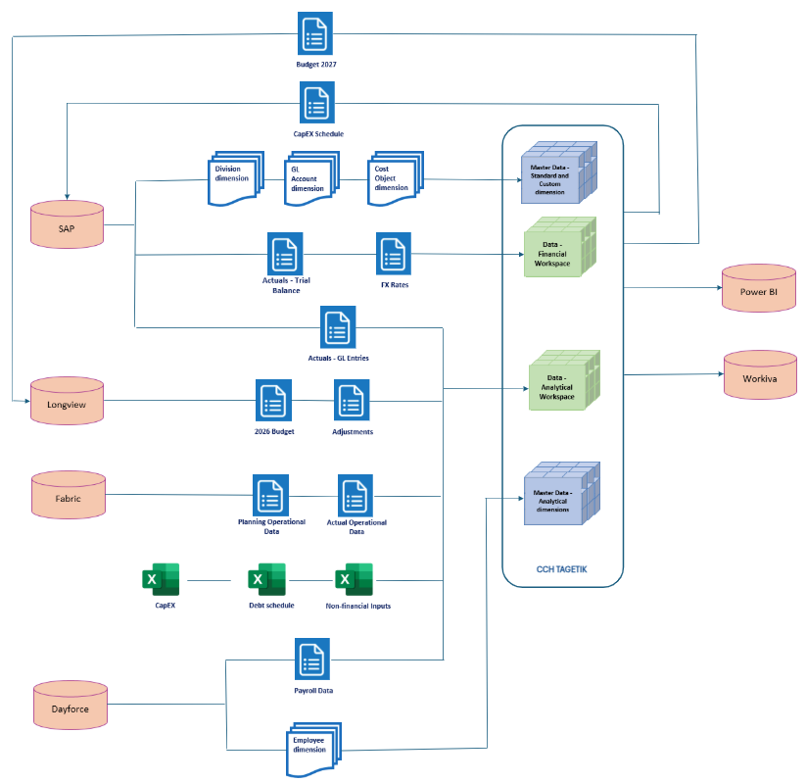

Source Data from SAP
Boralex will have most of the data coming from SAP and Fabric. Data not coming from SAP will be Longview Journal Entries, Excel, Fabric, Boralink, Dayforce, manual inputs - through input forms- and adjustments, etc.

Source Data from Longview
Boralex will import historical monthly and consolidated data related to Actual from Longview in the temporary state whereby the vision is to adopt Tagetik as the main consolidation and reporting tool in the future. All other source data will come from SAP. An ETL will be built to import directly from Longview. This will be a manual import process as no direct connection has been defined.

Tagetik Application Components and Specifics
Below is a list of modules and components that will be installed as part of this Project. Also included in the list are BLX specific approaches to the way these CCH Tagetik components will be setup and deployed.
- CCH Tagetik on Cloud for Consolidation and reporting. Modules/Application layers to be utilized are:
- AIH
- Financial Layer
- Boralex will have 2 different environments available:
- DEV: Development environment where the Tagetik team will work during the development phase for the system configuration and set up. This environment will have 2 databases, one for development and one for UAT where Boralex will mainly test and validate the various models built.
- PROD: Production environment which will be used by the user community on a regular basis. There are two databases in each environment. Database PROD#2 can be defined as PRE-PROD in its description.
- Both environments will be up and always running. The Development environment will remain on-line even after go-live in case there’s the need to fix some system issues as well as to develop and test future enhancements.

Tagetik Dimensionality
The Tagetik Financial Workspace data model is defined by dimensions. Dimensions are categorized as standard dimensions and custom dimensions. Tagetik has 6 standard dimensions and can have up to 5 custom dimensions in the Financial Workspace, plus an unlimited amount of analytical dimension in the analytical layer.
Below is the list of standard dimensions:
  - Scenario
  - Period
- Category
  - Entity à Division
  - Currency
  - Account (including GL accounts and non-financial indicators)
The following Custom dimensions will be used by Boralex:
- CustDim1: Cost Object ➔ this dimension will be used to store the Cost Object dimension (Cost Center, WBS, Internal Order)
- CustDim2: TBD è the dimensions will be opened to support enhancements that could be requested in the future. In the current project’s scope, this dimension is not used
  - CustDim3: TBD è the dimensions will be opened to support enhancements that could be requested in the future. In the current project’s scope, this dimension is not used
  - CustDim4: TBD è the dimensions will be opened to support enhancements that could be requested in the future. In the current project’s scope, this dimension is not used
- CustDim5: OTHER è the dimension will be used to store balance sheet account detail for use in reporting and analysis
CCH Tagetik’s Analytical Information Hub (AIH) which is geared to provide further analytical capabilities within the Tagetik application is also based on dimensionality. AIH has unlimited dimensionality that can be used in conjunction with datasets (subject to AIH license restrictions).
Please refer to the Data Model document attached to this BRD for a comprehensive list of dimensions identified.

Configuration of Standard Dimensions

Scenario
CCH Tagetik’s Scenario dimension represents the main time related dimension of analysis. It merges the concept of fiscal year (FY) and data version. Each element of the scenario dimension will represent a certain type of data (e.g., Actual, Budget, Forecast) for a given fiscal year.
The time bucket, represented by the “period” dimension in CCH Tagetik, is the month for all scenarios.
The scenarios function in conjunction with the concept of “Reference Scenarios”. Reference Scenarios streamline comparative reporting as the reports can dynamically pick up the Reference Scenario associated with a user’s Scenario selection eliminating the need to manually select the additional scenarios. This feature is of great value when moving from one year to the next. By using reference scenarios, Boralex will not need to manually update any reports. Up to seven Reference Scenarios can be defined for all scenarios. Reference Scenarios can be:
- Following Scenario (e.g., if current scenario is 2024ACT, Following Scenario will be 2025ACT)
- Previous Scenario (e.g., if current scenario is 2024ACT, Previous Scenario will be 2023ACT)
- Ref Scenario 1 to Ref Scenario 5 (e.g., if current scenario is 2025FCT, Ref Scenario 1 can be 2025ACT, Ref Scenario 2 can be 25Q1_25FCT)

Original Scenarios
Below is an example of how we will configure the scenarios– please note that further scenarios i.e., 2027ACT onwards.
Code | Description | Process | Previous | Following | Ref1-Ref5
2025ACT | 2025 Actual | ACTUAL |  | 2026ACT | TBD
2026BDG | 2026 Budget | BUDGET | TBD | 2027BUD | TBD
2025FCT_Q1 | 2025 Forecast | 2025 Q1 Forecast | 2025ACT | 2025FCT_Q2 | TBD
Note: Exact naming conventions will be defined during discussions with the Boralex team.

Consolidation Scenarios
Consolidation scenarios are used to store converted data system eliminations. Sub-consolidations will also be configured using Consolidation Scenarios. Below is an example of how we will configure the Consolidation scenarios. Please note that further scenarios i.e., 2027ACT_USD onwards… will be setup in the application by the system administrators:

Code | Description | Original Scenario | Previous | Following | Ref1-Ref5
2023ACAD | 2023 Actual CAD | 2023ACT |  | 2024ACAD
2023AUSD | 2023 Actual USD | 2023ACT |  | 2024AUSD
2024ACAD | 2024 Actual CAD | 2024ACT | 2023ACAD | 2025ACAD
2024AUSD | 2024 Actual USD | 2024ACT | 2023AUSD | 2025AUSD
2025ACAD | 2025 Actual CAD | 2025ACT | 2024ACAD | 2026ACAD
2025AUSD | 2025 Actual USD | 2025ACT | 2024AUSD | 2026AUSD
Note: Exact naming conventions will be defined during discussions with the Boralex team.

Snapshot Scenarios
In Tagetik, Snapshot Scenarios are used to support what-if analyses and comparative reporting, enabling users to simulate alternative versions of a planning scenario without impacting the original data. For each base scenario, the system allows the creation of up to 1,000 snapshot scenarios, which act as frozen copies of the original scenario at a specific point in time.
The creation and management of snapshot scenarios is typically part of the administrative maintenance activities, where the admin user assigns a version identifier (e.g., _001, _002, etc.) to each snapshot to ensure traceability and clarity.
For example, starting from the base scenario 2026FCT, an administrator can generate a snapshot scenario named 2026FCT_001 to capture the first iteration of the 2026 Forecast. Users can then continue working on the original 2026FCT scenario, while retaining the ability to compare current data with the version stored in 2026FCT_001. If needed, the snapshot version can be restored into the original scenario, effectively making it the new official version.
This functionality provides a flexible and controlled environment for iterative planning, versioning, and auditability, especially in complex forecasting cycles.

Periods
The Tagetik period dimension is the second time related dimension, and it represents the time-wise granularity of the data. Periods are associated to an element of the Scenario dimension. A scenario might have 12 periods, in case of monthly data: Or only 1 period in case of an annual scenario.
Boralex will have 12 periods set up in Tagetik to represent the 12 months of the year. The system will be set up such that the fiscal year will start in January to December. The periods will therefore be: 01 – Jan 02 – Feb, …, 12 – Dec.
Code | Description | Quarter
01 | January
02 | February
03 | March | 1st Quarter
04 | April
05 | May
06 | June | 2nd Quarter
07 | July
08 | August
09 | September | 3rd Quarter
10 | October
11 | November
12 | December | 4th Quarter

Currency
At Boralex, data is recorded in functional currency then translated to consolidation currencies CAD, GBP, EUR and USD. Multiple currencies can be setup in Tagetik to allow support multi-currency reporting. We will be setting up 4 currencies in the application:
Currencies
Label | Scale | Translation Operator | Description=English
* CAD | 0 | Divide | Canada Dollars
GBP | 0 | Divide | Great Britain Pounds (Pounds Sterling)
EUR | 0 | Divide | Euro
USD | 0 | Divide | United States Dollars
* CAD – Canada Dollars (will be configured default reporting currency)
Additional currencies may be setup as needed for consolidation and conversion purposes.

Categories
The category dimension is used to segregate data - the use of this dimension varies according to the implementation need and is usually driven by industry standards. A typical example might be a category used to store the dollars in an account while a different category might be used to store the annual assumptions used in data processing or calculations rule to project the value of the account in planning periods.
For Boralex, the category dimension will be used to label data and therefore the following category elements will be created:

Code | English Description | Français description | Category type
$AMOUNT | Default Original Amount | Default Original Amount | Amount
105 | US GAAP Original Amount |  | Amount
200 | Local Entity Adjustments | Local Entity Adjustments | Entity journals
300 | Fair Value Adjustments | Fair Value Adjustments | Entity journals
400 | Consolidation Adjustments | Consolidation Adjustments | Consolidator entity journals
500 | USGAAP Consolidation Adjustments | Consolidation Adjustments | Consolidator entity journals
900 | Financial Investment Elimination | Financial Investment Elimination | Consolidator journals
901 | Acquisition Entries | Acquisition Entries | Consolidator journals
905 | IC Elimination | IC Elimination | Consolidator journals
910 | Non-controlling Interest IFRS | Non-controlling Interest IFRS | Consolidator journals
911 | Non-controlling Interest US GAAP | Non-controlling Interest US GAAP | Consolidator journals
912 | Non-controlling Interest COMBINED | Non-controlling Interest COMBINED | Consolidator journals
915 | Dividend Eliminations | Dividend Eliminations | Consolidator journals
920 | Equity Investment Elimination | Equity Investment Elimination | Consolidator journals
925 | Profit in Stock Eliminations | Profit in Stock Eliminations | Consolidator journals
930 | Equity Pickup IFRS | Equity Pickup IFRS | Consolidator journals
931 | Equity Pickup US GAAP | Equity Pickup US GAAP | Consolidator journals
932 | Equity Pickup COMBINED | Equity Pickup COMBINED | Consolidator journals
936 | Equity Pickup on IFRS Journals | Equity Pickup IFRS Journals | Entity journals
937 | Equity Pickup US GAAP Journals | Equity Pickup US GAAP Journals | Entity journals
938 | Equity Pickup COMBINED Journals | Equity Pickup COMBINED Journals | Entity journals
FPA101 | Admin Costs - Note | Admin Costs - Note | Amount
FPA102 | Admin Costs - BU France | Admin Costs - BU France | Amount
FPA103 | Admin Costs - BU US | Admin Costs - BU US | Amount
FPA104 | Admin Costs - BU UK | Admin Costs - BU UK | Amount
FPA105 | Admin Costs - BU Canada | Admin Costs - BU Canada | Amount
FPA106 | Admin Costs - Corp France | Admin Costs - Corp France | Amount
FPA107 | Admin Costs - Corp US | Admin Costs - Corp US | Amount
FPA108 | Admin Costs - Corp UK | Admin Costs - Corp UK | Amount
FPA109 | Admin Costs - Corp Canada | Admin Costs - Corp Canada | Amount
FPA110 | Admin Costs - Not Transferred | Admin Costs - Not Transferred | Amount
H400 | Historical Consolidation Adjustments | Historical Consolidation Adjustments | Amount
H800 | GAAP Adjustments (Do not use) | GAAP Ajustements (Ne pas utiliser) | Amount
H801 | Trial balance - Outside SAP | Balance de vérification - Hors SAP | Amount
H802 | Input Base | Input Base | Amount
H803 | Rebilling Allocation | Refacturation d'allocation | Amount
H804 | Recurring Data | Données Récurrentes | Amount
H805 | Non Recurring Data - Adjustments | Données Non Récurrentes - Ajustements | Amount
H806 | Adjustment Forecast | Ajustement Forecast | Amount
H807 | Adjustments by JEs (IRFS and USGAAP) | Ajustements par JEs (IFRS et USGAAP) | Amount
H808 | Adjustments by JEs (IFRS only) | Ajustements par JEs (IFRS seulement) | Amount
H809 | Equity Pick-up Ajustment | Quote-part des résultats Ajustement | Amount
H812 | Ajustments before acquisition (number days) | Ajustements avant acquisition (nombre de jours) | Amount
H813 | Purchase Price Allocation | Allocations du prix d'achat | Amount
H817 | Reorganization Adjustment | Ajustement de Réorganisation | Amount
H818 | Discontinued Operations Calculated | Activités abandonnées calculées | Amount
H819 | Discontinued Operations Adjustments | Activités abandonnées ajustements | Amount
H820 | Cash Flow Discontinued Operations Reclass | Activités abandonnées reclass cash-flow | Amount
H821 | Proportionate data | Données proportionnelles | Amount
H822 | Proportionate data adjustments | Données proportionnelles ajustements | Amount
H823 | Adjustments by submit - Proportionate data | Données proportionnelles ajustements submit | Amount
H824 | Equity Pick-up Reversal | Quote-part des résultats Renversement | Amount
H825 | Proportionate data cash-flow reclass | Données proportionnelles reclass cash-flow | Amount
H826 | GAAP Adjustment | Ajustement GAAP | Amount
H827 | GAAP conso adjustment | Ajustement GAAP conso | Amount
H828 | CF GAAP AcqDisp manual | CF GAAP AcqDisp manuel | Amount
H829 | GAAP Adjustment (calculated) | Ajustement GAAP (calculé) | Amount
H830 | GAAP Adjustment (calculated) | Ajustement GAAP (calculé) | Amount
H831 | GAAP manual Reclass | GAAP reclassement manuel | Amount
H832 | GAAP Calculated Reclass | GAAP reclassement calcule | Amount
H833 | CF_GAAP_CALC_RECLASS | CF_GAAP_CALC_RECLASS | Amount
H905 | Historical IC Elimination | Historical IC Elimination | Amount
H910 | Historical Non-controlling Interest adjustment | Historical Non-controlling Interest adjustment | Amount
H935 | Historical Equity Pickup | Historical Equity Pickup | Amount
HISTADJ | Historical Entity Adjustment | Historical Entity Adjustment | Amount
HISTELIM | Historical Eliminations | Historical Eliminations | Amount

Category groupings will be based on workflow steps and submission and reporting requirements.
Some relevant groupings that will be created are the following:
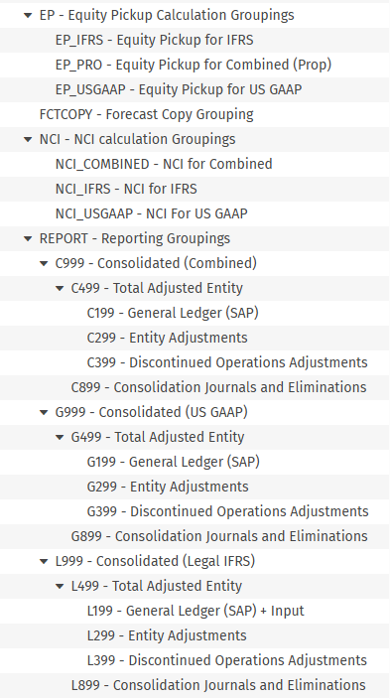

Note: Category codes and Grouping Codes are subject to change based on feedback from Boralex

GL Accounts
The account dimension is the dimension which contains the chart of accounts (COA). In Tagetik there are up to 4 different types of accounts:
- Accounts to store financial data
  - Profit and Loss accounts – e.g., Sales
  - Balance Sheet accounts – e.g., Cash
- Accounts to store non-financial (statistical) data
  - Other variation accounts – e.g., Number of days
  - Other stock accounts – e.g., Headcount, Square footage, etc…
A complete list of current accounts in Longview can be found on Teams.
Based on discussions to date, Boralex will use financial accounts and statistical accounts for the purposes of reporting. There will be the need to set up non-financial accounts during the design.
It has been determined that Boralex’s account list contains an excessively large number of balance sheet accounts. It is therefore recommended to reduce, streamline, the balance sheet accounts to eliminate the need to create a sizeable number of control groups and variation accounts related to the balance sheet.
To facilitate reporting, and ensure the detail is maintained, the current detailed structure for balance sheet accounts will be duplicated in the Custom dimension 5 (Other). This will allow Boralex to report on the account detail using the Custom dimension 5 while keeping the actual number of accounts and variations manageable. In addition, maintenance of the COA will be simplified as any new accounts in their SAP GL would simply need to be mapped to the primary balance sheet account and subsequently added to the Custom 5 dimension. So long as the new accounts fit within the existing structure, no additional maintenance would be required to reports or to the COA in CCH Tagetik.
The account dimension, as well as all the other Tagetik dimensions, support the creation of hierarchies. A hierarchy is a rollup of accounts achieved by aggregating base level account elements. Example of hierarchies may be an Account Code hierarchy where account elements are grouped by account nature (Balance Sheet vs Profit & Loss) or by accounting type (Sales accounts, Cogs and other costs accounts, Operating expenses, etc.).
Account hierarchies can be created:
- To answer reporting and data analysis needs
- To simplify the management of the user rights on the account dimension
- To simplify the selection of a group of accounts
Within a hierarchy, an account can only be associated with a single parent node. Below is an example of a correct hierarchy definition and an example of a wrong one:
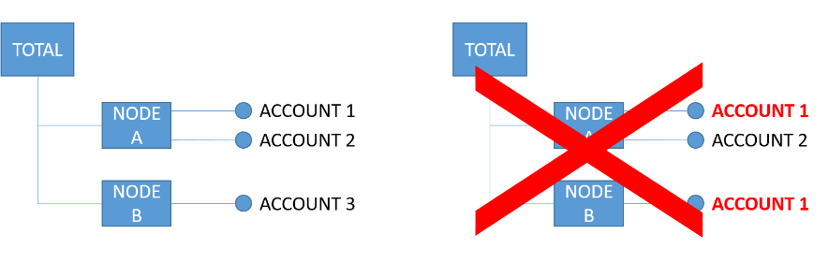
It is important to remember that data is always saved on the base-level individual accounts and never at the level of the hierarchy nodes.
The account hierarchies that will be included in the Boralex data model are as follows:
- Balance Sheet: this hierarchy organizes balance sheet GL accounts in the structure used for Balance Sheet reporting
- Income Statement: this hierarchy organizes P&L GL accounts in the structure used for Income Statement reporting
- Statistics: this hierarchy organizes any statistical or non-financial accounts in the structure.
Accounts and account hierarchies will be created and maintained manually by the Tagetik Administrator(s).
The list of Accounts that will be used in Tagetik together with their respective hierarchy rollups is currently under discussion. Once the list of Accounts is finalized together with their respective hierarchy roll ups, it will be added to the data model directly in Tagetik.
To support the reporting requirements that are currently represented in Longview, Boralex will use financial statement templates (FSTs), that are a standard Tagetik functionality. Tagetik team can configure FSTs during the project implementation phase (according to the current scope of the SOW) and will provide Boralex with the necessary knowledge to start defining FSTs autonomously. Boralex need to take a decision on which FST’s RCGT will build.

Account Elements
The Longview account elements will be used as the basis for CCH Tagetik’s account dimension.
Attached is the sample chart of accounts from Longview. The final COA will be provided by Boralex.
Note: The COA may be modified or updated prior to the build. Accounts can be recoded or deleted prior to the loading of data.

Account Hierarchies
CCH Tagetik contains a Default hierarchy which is primarily used for systems calculations and should not be modified. Additional hierarchies will be built for Balance sheet, Income Statement, Statistical Accounts, Variations, Cash flow, AFFO, Forecasting, and Supplemental reporting.

Cash flow Hierarchy
A sample Cash flow hierarchy has been provided to Boralex. They will be instructed on how to map variations into the CF hierarchy.
Most balance sheet variation accounts must be mapped to generate an automated cash flow by entity and consolidation node. It is expected that all variation accounts will be populated with data each period to enable Boralex to produce automated cash flow statements.

Statistical Accounts and Calculations
Statistical and calculation accounts are required. These calculations will be provided by January to December. It will be determined during the building if the calculations are to be created using MDX logic or via FST’s.

Variations
A preliminary list of Variation Detail Types has been provided to Boralex. Once a complete list of required variances has been provided by Boralex , it will be included in Data Model file.
Boralex must provide Variation Groupings along with the specific Normal accounts to which the groupings will apply.

Control Groups
Control groups are created by the system when variations are assigned to Normal accounts. Typically, all Normal Balance Sheet accounts will contain variation accounts and therefore there will be at least one Control Group per normal balance sheet account. Control groups can be used in reporting and forms design. Additionally, Control Groups can be grouped like the account hierarchy to facilitate reporting for variation accounts. Control Groups will be created during build phase of the project.
Note: The Control Group Hierarchy should ideally match the Balance Sheet Hierarchy to simply report writing and creation of the Cash Flow proof forms.

Entity – (Division)
In CCH Tagetik the Entity dimension is used to drive the data entry process, the operational workflows, the activity tracking, and the approval/submission process.
In Boralex’s application, this dimension will hold the Division. Lowest level elements representing the Divisions will then be organized in several hierarchies:
- Hierarchy by Legal Entity: in this hierarchy the Legal Entities will be represented by nodes and each Division will be attached to one Legal Entity
- Hierarchy by Technology: in this hierarchy the Technologies will be represented by nodes and each Division will be attached to one Technologies
- Hierarchy by Business Unit: in this hierarchy the Business Units will be represented by nodes and each Division will be attached to one Business Unit
- Hierarchy by Region: in this hierarchy the Region will be represented by nodes and each Division will be attached to one Region
- Hierarchy by Site: in this hierarchy the Site will be represented by nodes, and each Division will be attached to one Site

Legal entity organisational charts: (please disregard the definition/illustration of power plant in these documents for dimensionality purposes)
The maintenance of the Entity dimension (elements/hierarchies) is automated in Tagetik based on maintenance done in SAP.

Configuration of Custom Dimensions

Custom Dimension 1 – Cost Object
The Custom Dimension 1 is a dimension that can be used both in the Financial and Analytical workspaces.
In Boralex’s application the Custom Dimension 1 contains the following types of elements:
- Cost Centers
- WBS
- Internal Orders
Lowest level elements representing the Cost Objects will be organized in several hierarchies:
- Hierarchy by Type: this hierarchy will have three nodes; the node CC will contain all Cost Centers, the node WBS will contain all the WBS and the node IO will contain all the Internal Objects. It will be used to distinguish between the three types of Cost Objects in reporting or during the implementation of calculation logics.
- Hierarchy by Department: in this hierarchy the Departments will be represented by nodes and each Cost Object will be attached to one Department
- Hierarchy by Project: in this hierarchy the Projects will be represented by nodes and each Cost Object will be attached to one Project.
- Hierarchy for Reporting: in this hierarchy the Cost objects will be sorted by reporting type to facilitate reporting.
The list of Cost Objects will be updated automatically using SAP as source system.

Custom Dimension 2 – TBD
This dimension contains the list of xxx managed by Boralex.

Custom Dimension 3 – TBD
This dimension contains the list of xxx managed by Boralex.

Custom Dimension 4 – TBD
This dimension contains the list of xxx managed by Boralex.

Custom Dimension 5 – Other
This dimension contains a list of detailed balance sheet accounts managed by Boralex. It is designed to reduce the overall number of elements in the Accounts dimension while preserving the necessary level of detail for balance sheet and cash flow preparation, internal reporting, and analysis.

Configuration of AIH Dimensions and Datasets

AIH Dimensions
Analytical Information Hub (AIH) allows for referencing of financial layer dimensions (standard and custom) and usage of them in AIH datasets, so for the Trial balance upload into AIH, it will not be necessary to create additional analytical dimensions other than the ones existing in the financial layer. Analytical dimensions may be created for technical reasons to support future build phases related to budgeting and planning or forecasting.

Contract Type Analytical Dimension
The Contract Type dimension will be created to store the different Contract Types that are needed to track revenues accordingly.
This dimension will be manually maintained.

A hierarchy will be defined within this dimension to distinguish between:
- Non-Merchant
- Merchant
This hierarchical structure will support aggregated reporting and comparative analysis across different commercial models.

TBD -> A finalized version of the list of elements, as well as the hierarchy structure and mapping, will be defined during the detailed design phase.

Production Losses Analytical Dimension
An additional analytical dimension, Production Losses, will be created to enable the tagging of production losses.
This dimension is essential to support variance analysis and revenue calculation, by categorizing losses such as:
- Curtailment
- Biodiversity constraints
- Grid-related issues
- Internal losses

TBD -> A finalized version of the list of elements will be defined during the detailed design phase.

Asset Class Analytical Dimension
An analytical dimension called Asset Class will be created to track the different types of assets involved in the CAPEX and Debt issuance planning process.
This dimension will enable classification and reporting across various asset categories, supporting investment analysis, budgeting, and strategic decision-making.

TBD -> A finalized version of the list of elements will be defined during the detailed design phase.

Employee Analytical Dimension
The Employee dimension is used within the Workforce Planning module to manage and analyze employee-related data across the organization.
This dimension will be automatically maintained through an integration with Dayforce, ensuring up-to-date and consistent employee records.

The Employee dimension will serve as the central reference point, linking to other related dimensions such as:
- Job Title
- Department
- Location

Statistical WBS
To be able to assign specific costs to both a Cost Center (Custom dimension 1) and a “Statistical” WBS, a second dimension will be created.
This dimension will contain a list of available Statistical WBSs based on the SAP elements and will be made available in the data collection forms for specific costs to be collected, as an optional field. It will be used then to be able to report the total cost associated to a specific Statistical WBS.
The list of elements and eventual hierarchies are yet to be defined.

Power Plant
The Power Plant will be created as a dimension to support the Revenues Planning module in CCH Tagetik.
There is a direct connection between the power plants and the Division (Entity dimension).
The Power Plant will be used to store Capacity and Production metrics, that serve as a base for the Revenues calculation and other variable Revenues/Costs.
The following hierarchies will be created on top of the Power Plant dimension:
- Division: to map each power plant to a specific division
- Type: to distinguish between Master Plant, Power Plants and Other
- Region: to assign each power plant to a specific region
More details around this dimension can be found in the Data Model specific attachment.

Department/Region
The Department / Region dimension is a technical analytical dimension created to manage the budget ownership responsibility for the collection and approval of Asset Management, Development and Administrative costs.
This dimension was identified as necessary because it is not possible to limit budget responsibility solely to the Division (represented via the geographical organizational structure) nor exclusively to the Department (which represents the cost structure).
For instance, a budget owner may be responsible for a specific Region (e.g., “Canada – Quebec”), but not for all the Departments within that Region. Likewise, there is no single global budget owner responsible for a specific Department across all Regions. By concatenating these two attributes — the geographical (Region) and functional (Department) dimensions — the system ensures that users can enter, certify, and approve only the data elements falling within their respective budget or approval scope.
The elements of this analytical dimension are created based on the concatenation of the Region code and the Department code (three digits), separated by an underscore. The element code is always written in uppercase, while the element description uses proper case.
For example:
- The element corresponding to the Region Quebec and the Department Direction Operations has the code CA-QC_800 and the description Quebec Direction Operations.
- Similarly, the element for France Nord Operations has the code FR-NORD_800 and the description France Nord Operations.
Several hierarchies will be built on this dimension to support data collection, submission, and approval workflows across different FP&A modules. Specifically:
- Asset Management Cost Model Hierarchy
Includes hierarchical nodes based on geographical organization (Business Unit, Country, Region), with Department / Region elements as the leaf level.
Only Department / Region elements relevant to the Asset Management module will be included in this hierarchy.
- Development Cost Model Hierarchy
Follows the same geographical roll-up logic (Business Unit, Country, Region) and uses Department / Region elements as leaves.
TBC – To be confirmed once the Development Cost Model design is finalized.
- Administrative Expenses Model Hierarchy
Structured with Business Unit, Country / Department, and Department / Region elements as leaves.
Each hierarchy will include only the Department / Region elements necessary to cover the scope of the corresponding module.
More hierarchies might become necessary while exploring more modules in detail.
This dimension will be automatically maintained within the ETLs that update the Division and the Cost Object Dimensions, using the information coming from SAP.

Project Stages
The Project Stages dimension is a new analytical dimension introduced to classify development projects according to their lifecycle stage.
Its primary purpose is not tied to data collection activities, but rather to assign development costs to a specific stage and to enable reporting and analysis by project phase.
This allows Boralex to compare Actual vs Budget/Forecast at a development-stage level rather than at the project level alone, providing clearer visibility on the progress and cost performance of the portfolio.
The dimension contains four predefined elements, representing the stages used by Boralex to categorize development activities:
- 000 – Prospection
- 001 – Early Stage
- 002 – Mid Stage
- 003 – Advanced Stage
Codes are numeric and uppercase, while descriptions follow proper case format.
For Actual periods, the Project Stage assigned to each cost will be loaded from Fabric as part of the operational data integration.

For planning periods, the stage will be determined manually at project level, based on the expected start date and end date of each stage within the forecasting horizon.
The detailed use of this dimension within the Development Cost Planning Model is further explained in the dedicated chapter of this document.

Other Analytical Dimension
In addition to the main analytical dimensions (e.g., Contract Type, Asset Class, Employee), several technical and module-specific dimensions will be created to support standard processes within the Workforce Planning and Capex Planning modules.
These dimensions will include, but are not limited to:
- Job Title
- Bonus Type
- Other operational or planning-specific classifications
These dimensions are designed to enhance flexibility and granularity in planning, reporting, and analysis, and will be maintained either manually or through system integrations depending on availability and relevance.

AIH Workspaces and Datasets
The following Workspaces will be created in the CCH Tagetik Analytical Layer:
- Actuals and Configuration
- Revenues and Opex à Detailed Datasets will be defined at a later stage
- Workforce Planning à Based on the Workforce Planning Starter Kit workspace
- CAPEX and Debt Issuance Planning à Based on the CAPEX Planning Starter Kit workspace
In the Actuals and Configuration workspace, the following analytical datasets have been identified:
- One dataset to stage Actual data prior to loading to the financial layer. Data stored can be used for a multitude of purposes such as Account reconciliation, analysis by customer/vendor, etc. and depends on the amount and type of data imported. Please see the Data Integration Document (DID) for additional information related to data integration.
- Boralex must provide an updated sample data file from SAP to enable completion of the DID documentation.

Tagetik System Processes
Within the Tagetik application, the concept of “Process” is the key to how the application performs certain activities. Tagetik best practices dictate that separate processes be setup to allow the application to behave in different ways depending on the functionality required for each business cycle/process. For example, in the actual process, trial balance data will be loaded into the application. Therefore, an account such as Employee Salaries would come directly from the trial balance. However, for budgeting purposes Employee Salaries could be calculated as the multiplication of the number of employees by a monthly amount. Therefore, the behavior of Employee Salaries is different depending on the process. The process models allow for this differing behavior to occur. In addition, different processes enable to capture the specific operational/approval workflows and organizational structures of the various business processes performed by the company.

Standard Consolidation Rules
The standard consolidation rules established within Boralex’s application includes automated handling of full consolidation for subsidiaries, Minority Interests (Non-controlling Interests), Joint Ventures and associates accounted for under the equity method, and consolidation journals for structural adjustments. A separate proportional consolidation process will be available to support internal reporting requirements, enabling joint ventures and associates to be reflected proportionally across financial statements. Intercompany eliminations will be systematically applied to remove intra-group transactions and ensure accurate consolidated results. The process will also incorporate currency translation for foreign entities using appropriate exchange rates, alignment of accounting policies across all entities—including reconciliation between IFRS and US GAAP where applicable—and support for multi-dimensional reporting across Legal, Technology, Geographical, and Business Unit hierarchies. It is important to note that balance sheet reporting and eliminations are not included within the soft consolidation process; these will be addressed exclusively through the formal consolidation framework, which applies to actual data only.

Consolidation Area’s (Data Processes)
The consolidation Area’s are used to define the entities included in the Consolidation Scenarios, as well as their consolidation methods. Legal Consolidations will be defined using the Legal Entity Hierarchy. Sub-consolidations will be defined for the Divisions/BU’s in EUR (Europe), in USD (United States), and GBP for the UK. Technology sub-consolidation will be defined in CAD. A regional sub-consolidation will be defined in CAD. A Combined sub-consolidation will be defined in CAD for Joint venture reporting.
Notes:
The consolidations will be required for all Scenarios and Years.
Additional sub-consolidations and consolidation currencies can be defined as needed. Keeping in mind that Boralex will be responsible for all data validation steps.

A sample of Consolidation areas that will be configured is as follows:
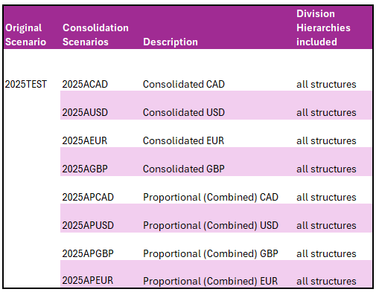
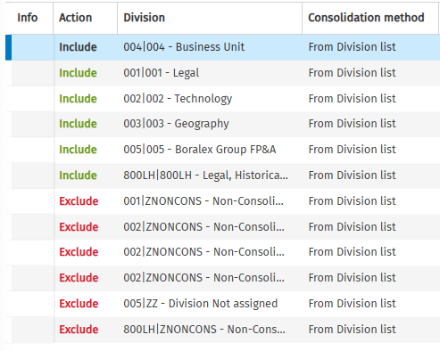

Actual Process
The actual process will be used to load Actual data into the system from different external sources:
- Trial Balance Data from Boralex’s SAP ECC6 ERP.
- Excel
- Longview (Historical data)
- Fabric
This data will be utilized for reporting and refreshing forecast data as well. One Tagetik Actual process will be created in the system to house Actual data.
Tagetik Process code | Tagetik Process description | Information
ACTUAL | Actual process | Actual Process – it will include all the scenarios that gather actual data
On a monthly basis, Boralex will upload their actual figures by using a manual ETL process. Details are stated in the Data Integration Section.

Actual Monthly Loads
The Actual Data Process Model (ACTUAL) will be designed to load actuals from all relevant data sources. A dedicated Consolidation Business Workflow will be attached to this process model to support end-to-end consolidation activities. Actual data will include a full month’s trial balance by division—beginning with Period 12, December 2025 —along with additional detailed accounts required for reporting and analysis. ETL processes will be developed for each unique data source to ensure accurate and timely data integration. All data will be loaded into the application in the local currency of each division. Rebuild periods will be loaded in Local Currency (LC) to the Original Scenarios and subsequently converted using the consolidation data processing logic. The Actual Process will serve as the primary data source for the formal consolidation framework, which applies exclusively to actual data. At the consolidated level, amounts will be translated, eliminated, and aggregated in accordance with standard consolidation rules. These rules include automated handling of full consolidation for subsidiaries (divisions), Minority Interests (Non-controlling Interests), Joint Ventures and associates accounted for under the equity method, and consolidation journals for structural adjustments. A separate proportional consolidation process will be available to support internal reporting requirements, enabling interests in Joint Ventures and associates to be reflected proportionally across financial statements. Intercompany eliminations will be systematically applied to remove intra-group transactions and ensure accurate consolidated results. The process will also incorporate currency translation for foreign divisions using appropriate exchange rates, alignment of accounting policies across all divisions—including reconciliation between IFRS and US GAAP where applicable—and support for multi-dimensional reporting across Division, Technology, Geographical, and Business Unit hierarchies. During the initial period (Period 12) prior to the real consolidation of actuals in Tagetik (phase 4), only balance sheet data will be loaded to facilitate the roll-forward of opening balances into the first full rebuild period. Consolidated results will be stored in the designated Consolidation Scenarios."

Planning Processes and Modules

Planning Modules
The FP&A function within Boralex encompasses a comprehensive set of planning, reporting, and forecasting activities across multiple business dimensions. The implementation of CCH Tagetik aims to centralize and streamline these processes, replacing fragmented tools and manual workflows with an integrated platform.
Scope Overview
The FP&A scope includes the following core modules, each designed to support specific planning and reporting needs:
- Revenues and Production Planning. Focuses on forecasting production volumes, losses and pricing to derive production revenue projections.
- Asset Management Costs. Supports bottom-up planning of maintenance and operational costs for existing energy assets.
- Development Costs. Tracks capitalized and non-capitalized costs for new projects and developments.
- Administrative Expenses. Covers overhead and operational costs, enabling detailed cost center, division and department planning for G&A Opex.
- Profit & Loss (P&L) Reporting. Provides detailed management reporting by region, including margin analysis and performance tracking.
- Workforce Planning. Employee-level planning of annual salaries and headcount, with local assumptions by region/country.
- Capital Expenses and Debt Issuance planning. Includes project-level depreciation schedules and investment planning.
- Forecasted Cash Flow. Enables AFFO and revolving debt calculations.
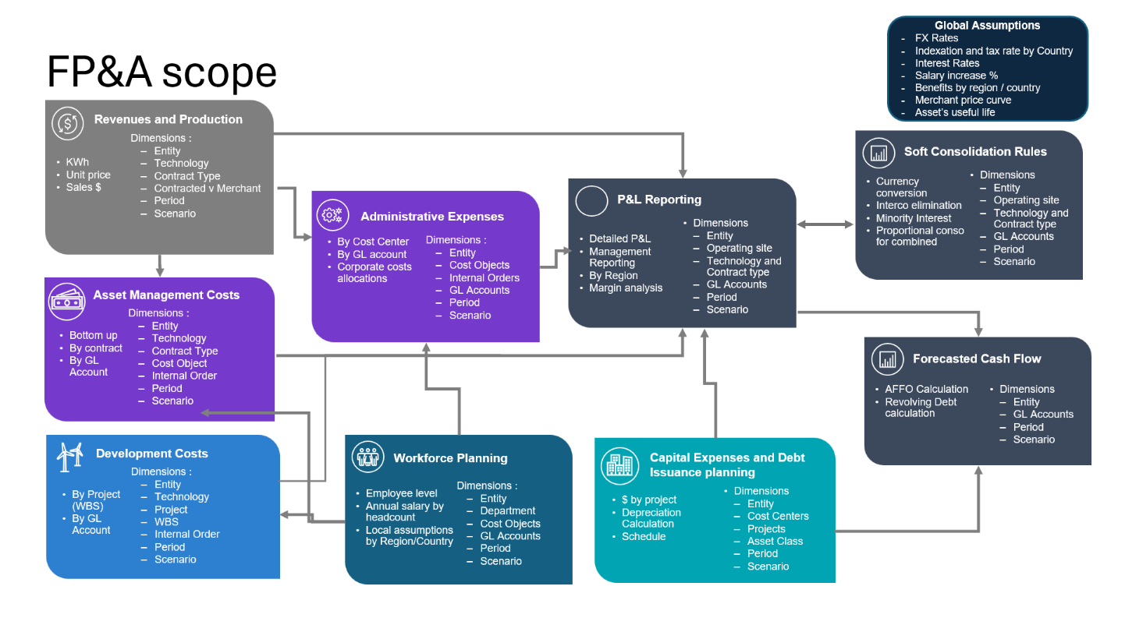

Planning Cycles
The planning cycles within the FP&A function are evolving to support more agile and data-driven decision-making. The transition to CCH Tagetik enables a phased transformation of the planning cadence and toolset.
Current State (As-Is)
- Yearly Budget: Managed in Longview, initiated in August with consolidation by Business Units and finalization by Group in November. Data is presented to the Board in December and is uploaded to SAP in January.
- Quarterly Forecast: Conducted in Excel, based on actuals and budget as a baseline.
Target State (To-Be)
- Quarterly Forecast: Transitioned to Tagetik, enabling scenario-based planning and integration with actuals. This process is the target for the first Tagetik rollout in Q1 2026.
- Yearly Budget: Fully managed within Tagetik, shortening the current timeline but improving collaboration and traceability.
Future State
- Monthly Forecast: Introduced to support more frequent performance reviews and proactive adjustments, leveraging CCH Tagetik capabilities.
- Long term planning: High level strategic plan including capital allocations, project growth and life production plan cycle (up to 40 years)
- Rolling Forecast: Implemented to provide continuous planning visibility, with the budget becoming a snapshot of the rolling forecast.
- Predictive forecast leveraging AI functionalities: It involves the use of data, statistical algorithms, and machine learning techniques to identify the likelihood of future outcomes based on historical data and trends.
- Sensitivity analysis and anomaly detection using AI: using artificial intelligence to evaluate how changes in a system's inputs, assumptions, or model structures affect its outputs, helping to identify critical factors, understand system behavior, and inform decision-making

Revenues Planning
The Revenues Planning process provides a structured framework for forecasting and budgeting revenues across all business units and regions. It integrates production forecasts, anticipated production losses, and price assumptions to ensure accurate and transparent revenue projections.
The scope includes both primary revenues from energy production and secondary revenues, such as compensations, services, and aggregation fees.
To support this process, a dedicated Workspace will be created within the Analytical Information Hub, leveraging key analytical dimensions such as Power Plant, Contract Type, and Production Loss Categories.
Throughout this section, we refer to an Excel attachment that outlines the expected workflow structure, tasks, and data collection forms to be implemented in the Tagetik application. The attachment is available here: link

Dimensions and Granularity
Revenues will be planned at a monthly granularity, with the ability to aggregate to quarterly and annual views leveraging the standard CCH Tagetik reporting capabilities.
Key dimensions for this module include:
- Scenario
- Period
- Division
  - Technology
  - Region
- Power Plant
  - Region
- Account
  - GL accounts for Revenues
  - Statistical Accounts for Production and Prices
- Contract Type
- Contracted vs Merchant
- Production Loss Type

Organizational Hierarchy, Responsibility and Workflow
At Boralex, revenue planners are assigned to specific Power Plants and Divisions based on geographic distribution. This structure also defines the levels of data collection, submission, and approval.
A high-level visualization of the organizational hierarchy and approval levels is provided in the attached Excel file.
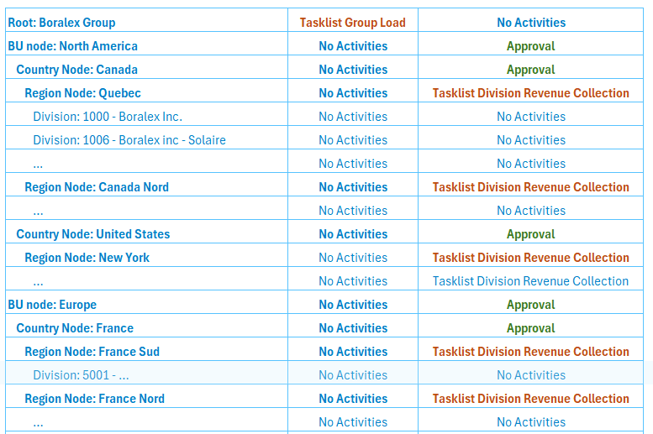
We have identified 2 main steps in this process:
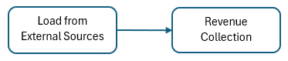
- Load from External Sources
Managed centrally by an Admin Business User or Power User, this step involves preparing the forecasting process and uploading data from external sources (e.g., Fabric, SAP, Excel).
- Revenue Collection
Managed at the Regional Level for data entry and at the Country and Business Unit Levels for approvals.
Each step includes a set of tasks to be performed by admin and contributor users. A visual representation of the workflow tasks is available below, and in the attached Excel file (available at the beginning of this section):
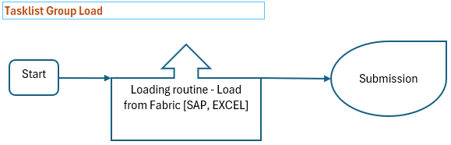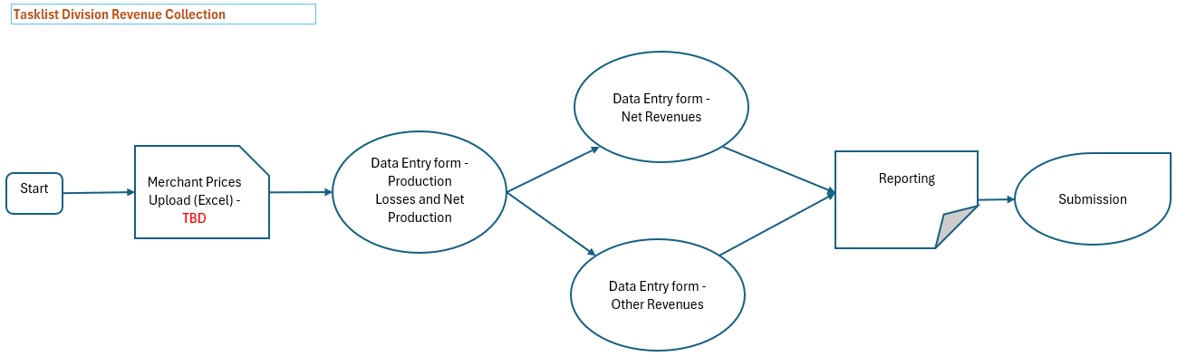
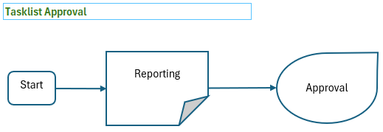

Data Collection
Three distinct data collection forms have been identified for contributor users:

Planned Production Losses
This data collection form will be used to plan the expected production losses for the year, as a loss % for the whole year, by Division. This form will show all the Divisions available for a selected Region (based on the Planner’s scope) and will show the expected yearly production as per the uploaded information from Fabric (P50). The user will add the planned production loss types in columns, as needed, picking from the available list of production loss types.
The user will have the option to indicate an expected split across the different months for any production loss type available. If a monthly split is not indicated, the system will automatically split the loss using the planned production as a proportional driver.
On the actual periods, it’s possible to add a % of split that will not anyway affect the actual production losses available in the following steps of the process. It is only used as a reference to split the total yearly losses across all the months of the year.
Below you can find a screenshot of how the data collection form will look like. A detailed version of this mock-up is available in the attached Excel file at the beginning of this section.
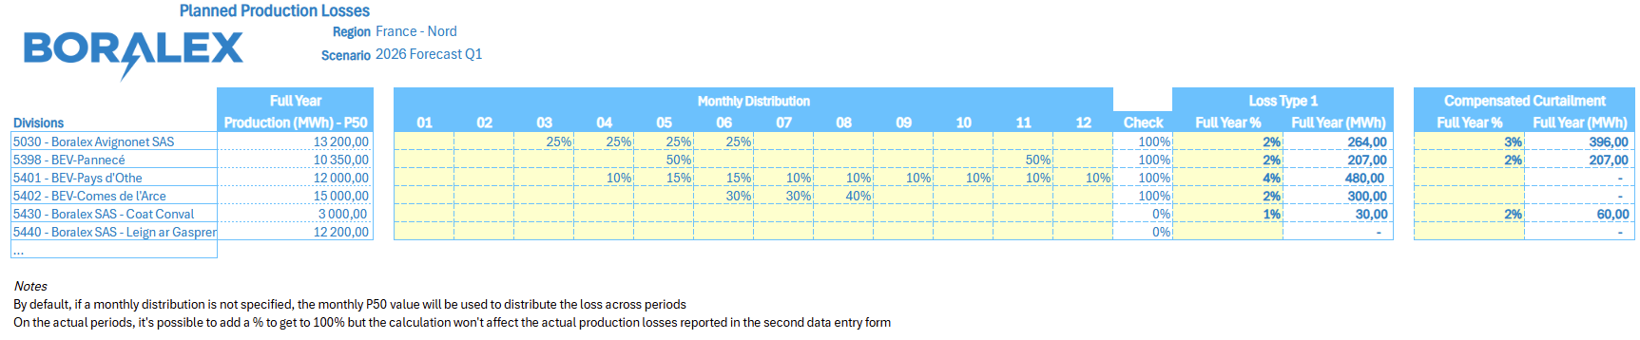

Net Revenues Collection
This data collection form will be used to calculate and derive the $ amount of Net Revenues by Production sold, and to collect the different revenues by Contract Type and by Compensation from compensated losses.
The data collection template is showing, on the rows, a specific Division, and the relevant contract types for that Division.
On the top part, the template will show the output of what has been planned in the previous data entry form, including the monthly values for the actual (from Fabric) and planned production (P50), the production losses, and the calculated net production.
In the middle section, the user is able to manually enter the expected production sold by contract type, and the expected average price, in order to define the planned Net Revenues in $ per contract type; the merchant sold production and the related revenues will be calculated as a delta between the total net production and the production sold to the different contract types.
At the bottom of the template, the total production sold will be shown, and the total net revenues will be calculated, together with the final AVG Price in $/MWh. There will also be the possibility for the planner to Indicate an expected Compensation from production losses, in order to calculate the AVG Price from Compensations (as Compensation $ / Compensated Production losses in MWh) and a final Effective Average Price (based on the total Revenues (from electricity sold + compensated from the losses , divided by the Net Sold production).
Below you can find a screenshot of how the data collection form will look like. A detailed version of this mock-up is available in the attached Excel file at the beginning of this section.
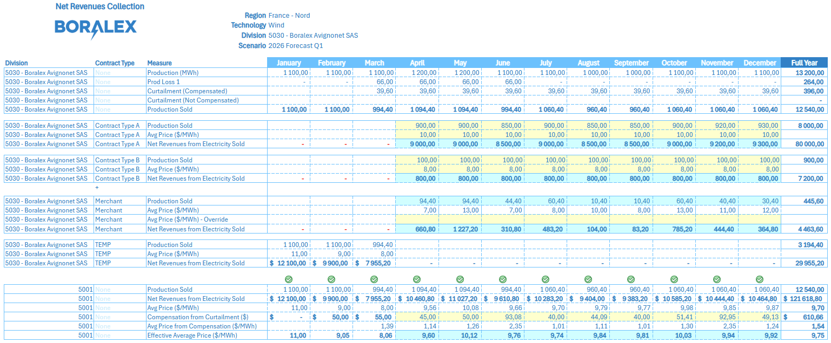

Other Revenues
This data collection form allows to collect non-core revenues that are not directly derived from the production sold or from the compensation from production losses. These revenues are collected by Division and GL Account.
On the top part of the data collection form, the planners will have the possibility to enter, per Division, an Aggregation Fee Price, that the system will use to derive the monthly Aggregation Fee cost based on the monthly Net Production sold.
Right below that, a table with Division / GL Account in rows and with the actual/forecasted months in columns can be used to manually enter/edit the other revenues directly in $value. The form will be pre-seeded with actual revenues by GL account coming from SAP, and with Budget data on the forecasted periods based on the Longview budget for the first year, and the Tagetik budget for the following forecast cycles.
Below you can find a screenshot of how the data collection form will look like. A detailed version of this mock-up is available in the attached Excel file at the beginning of this section.
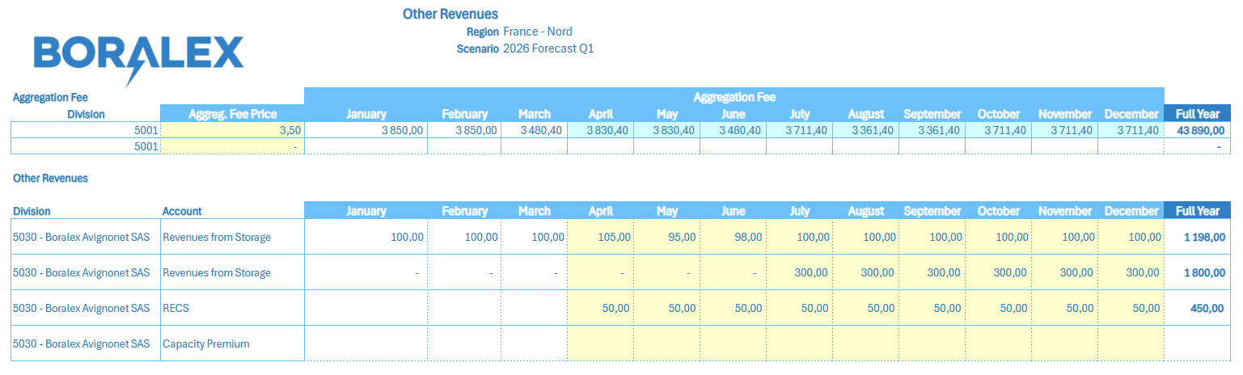

Data Integration
As part of the Revenues model, actual and planned data will be sourced as follows:
- SAP: Actual financial revenues data, as part of the monthly Trial Balance data upload
- Fabric: Actual production in MWh, planned Production (P50) in MWh, plant capacity data, and planned production losses. Also, Power Plant master data, mostly relevant for revenues planning purposes, will be sourced from Fabric
- Excel: Planned Average Merchant prices
- Excel: Planned Production and Prices by Contract type, mass upload for initialization

More detailed information regarding the data format, the data governance and the upload frequency in Tagetik is available in the Data Integration document, available here: link

Data Processing
In order to support the calculation logic related to the Revenue Planning process, a set of Data Processing will be developed within CCH Tagetik AIH (Analytical Information Hub).
These calculations will be implemented as Data Transformation Packages (DTPs), each designed to perform a specific data preparation or initialization task required by the planning workflow.

Production losses form initialization
This DTP is responsible for initializing the Production Losses data entry form by retrieving and processing production data from the P50 dataset.
More specifically, the DTP will:
- Extract production values from a staging dataset in AIH, which contains the P50 production data sourced from Fabric.
- Aggregate the monthly P50 values to calculate the annual expected production for each power plant and Division.
- Automatically open (initialize) the relevant data entry form rows at Division level, displaying the calculated annual production values.
Once initialized, the data entry form will allow users to:
- Input the expected annual production losses, expressed as a percentage of the total annual production.
- Optionally define a monthly distribution of the same losses, also expressed in percentage terms.
- Enter multiple types of production losses for each Division, if applicable.
This data processing ensures that the production loss planning process starts from accurate and up-to-date P50 planned production figures, providing users with a structured and automated form initialization.

Production losses and Net Revenues calculation
This DTP is designed to calculate the monthly impact of planned production losses and to derive the resulting Net Revenues from Electricity Sold as part of the Revenue Planning process.
The following calculations will be applied only to planning periods. For the actual periods, the DTP will instead perform a pre-seeding initialization of the data entry form by retrieving actual production data and production losses loaded from Fabric, as well as any available information related to contracted and merchant production volumes and prices, as well as the actual Net Revenues imported as part of the monthly Trial Balance.
Starting from the P50 nominal planned production monthly values, and the user’s input, the DTP will:
- Apply the production loss percentages entered by users in the previous data collection step,
- Compute the monthly planned production losses for each budget/forecast month,
- Derive the corresponding Net Production, obtained by subtracting the total losses from the P50 planned production.
Once the Net Production is determined, the DTP will:
- Apply an Average Merchant Price (expressed in $/MWh) to calculate the Net Revenues from Electricity Sold.
- Store the Net Revenues from Electricity Sold in the relevant currency (e.g., CAD or other local currency, depending on the division currency).
If the company sells part of its production under specific contract types, users will be able within a data collection form, to:
- Enter the volume of production sold by contract type and the average price associated with each contract.
- Then, the system will then directly calculate the Net Revenues from Contract Sales in the data entry form.
- Consequently, the Merchant Net Revenues previously calculated will be adjusted (reduced) by the value of these contract revenues — ensuring that merchant revenues represent only the portion of production sold on the open market (i.e., total net production minus contracted production).
All subsequent calculations — including:
- Revenues from Compensation due to Curtailment, and
- the Effective Average Price (which considers both revenues from electricity sold and from compensation)
will be handled directly within the data entry form, at saving time.
This DTP ensures that all key revenue metrics, from gross to net production and from merchant to contracted revenues, are consistently derived from user inputs, P50 baseline data and the average merchant prices.

Other Revenues Forecast initialization
This DTP is designed to initialize the Other Revenues data collection form by retrieving actual and forecast data from source systems and pre-populating the form with the relevant information.
More specifically, the DTP will:
- Extract Actuals from the Trial Balance loaded from SAP.
- Retrieve Budget data from SAP (from the budget done in Longview), used as the initial reference for forecast periods.
- Starting from the second forecast cycle, the previous forecast done in Tagetik will be used as a baseline for the open forecast periods
- Filter the extracted data based on a predefined list of GL accounts specifically related to Other Revenues.
- Load these values into a dataset used as a baseline for the Other Revenues data entry form, with monthly granularity until year-end.
This process ensures that users can start the forecast cycle with a pre-initialized form populated with both historical (actual) and reference (budget) data, aligned to the company’s chart of accounts.
A specific Other Revenue component, the Aggregation Fee, will be calculated directly within the same data entry form impacted by this DTP. In this case, users will be able to input an Aggregation Fee Price, and the system will automatically calculate the Aggregation Fee amount by multiplying the entered average price by the plant’s production volume.

Final Data Mapping and Transfer to Financial Workspace
This DTP represents the final step of the Revenue Planning process and is executed once all data collections and user adjustments have been completed, resulting in the finalized forecast for Production Revenues and Other Revenues.
The main objective of this data processing is to map and enrich the data stored in the Analytical Information Hub (AIH) to make it compatible with the structures and standards required by Tagetik Financial Workspace and the related Financial Reporting environment.
Specifically, the DTP will:
- Map all relevant metrics and measures to their corresponding GL accounts, whenever not already defined (e.g., in the case of Production Revenues or Aggregation Fee), and retain the GL account association already present for Other Revenues, as those are collected at account level.
- Populate and enrich additional fields required for reporting, such as:
  - Custom Dimensions, if needed
  - Tagetik Category
  - Division (when not explicitly defined in the previous steps, it can be derived from the Power Plant / division mapping).
- Structure the output dataset in a format fully compatible with the Financial Workspace import process, ensuring that the data can be seamlessly integrated and used within Financial Reporting and P&L Reporting templates.
This DTP ensures full alignment between the Revenue Planning output and the company’s financial reporting standards, allowing the final forecast data to be consistently consolidated and analyzed within the broader financial ecosystem of Tagetik. Consolidation of the data will occur in accordance with the standard consolidation rule established with the Boralex application.

Asset Management Costs Planning
Asset Management Costs cover the operating expenses associated with maintaining and operating energy assets. This includes fixed and variable costs, as well as recurring and one-time expenses.
The Asset Management Cost Model in Tagetik has been designed to support the end-to-end planning process of these costs, from data initialization and integration with SAP and Longview, to user data collection, review, and approval workflows. The model ensures alignment between financial planning and operational accountability by leveraging a dedicated analytical dimension (“Department / Region”) to manage responsibilities across both geographical and functional structures.
Throughout this section, we refer to an Excel attachment that outlines the expected workflow structure, tasks, and data collection forms to be implemented in the Tagetik application. The attachment is available here: link

Dimensions and Granularity
Asset Management Costs will be planned at a monthly granularity, with the ability to aggregate to quarterly and annual views leveraging the standard CCH Tagetik reporting capabilities.
Key dimensions for this module include:
- Scenario
- Period
- Division
  - Region
- Cost Object
- Department
- Department/Region: for data collection, submission and approval
- GL account
  - GL accounts for Asset Management costs, variable and fixed
- Statistical Accounts for Production and Capacity that can be used to derive some variable costs, and other Statistical accounts used to collect general assumptions like local taxes

Organizational Hierarchy, Responsibility and Workflow
In Boralex, Asset Management Costs are under the responsibility of the respective Asset Managers, organized by Department and by Region, reflecting both functional and geographical structures.
This organizational setup will be used to define the data collection, submission, and approval processes within the Budget and Forecast cycles.
To properly manage data ownership and workflow responsibilities, a new technical analytical dimension has been created: Department/Region. This dimension concatenates information from both the geographical hierarchy — covering Regions, Countries, and Business Units — built on top of the Division dimension, and the functional hierarchy, represented by Departments, built on top of the Cost Object structure.
For the Asset Management Costs, the relevant departments will be the ones with the code starting with “8”, and consequently the Department/Region elements available in the workflow for this process will be the ones concatenating the regions and the “8XX” departments.
Below is a graphical representation of the expected organizational hierarchy supporting the process.
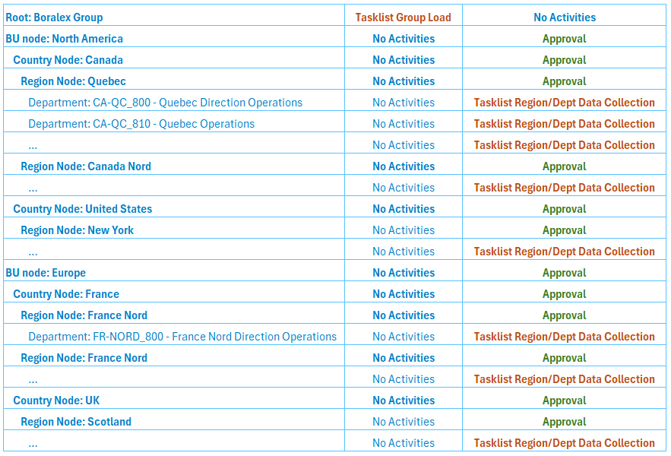
The workflow for the Asset Management Cost Model consists of two main steps:
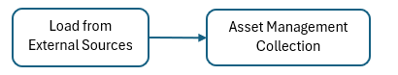
- Load from External Sources
Centrally managed at Group level; this step involves the loading of data from external systems, such as SAP (e.g., Trial Balance and Master Data).
Module Initialization, with reload of Actuals and Budget / Forecast data, can be performed also at BU level, impacting only the department / region elements pertaining to that BU.
- Asset Management Cost Collection
Managed at the Department/Region level, this step enables the data collection process for cost planning, with submission and approval performed at higher levels (Country and Business Unit).
It should be noted that the initial loading and initialization phase of the forecast process (step 1) may be shared with other planning modules. Therefore, while it is listed here as part of the Asset Management Cost Model workflow, this step may be executed jointly across multiple planning processes.
Each step includes a set of tasks to be performed by admin and contributor users. A visual representation of the workflow tasks is available below, and in the attached Excel file (available at the beginning of this section):
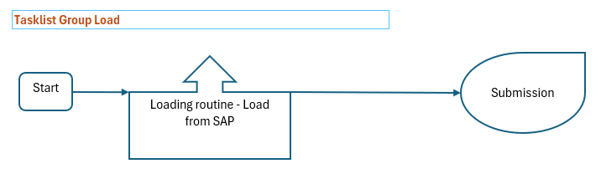
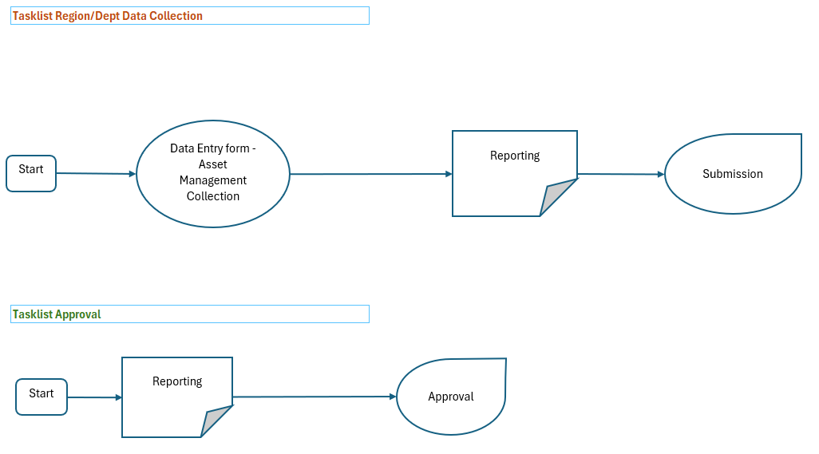

Data Collection
To support the Asset Management Cost Collection process, a single data entry form has been designed and will serve as the main interface for entering and reviewing the cost data. This form will be used by the Budget Owners of a specific Department/Region and will be directly accessible from the Workflow during Step 2 – Asset Management Cost Collection.

Asset Management Cost Collection
The form will have as input parameters the scenario, which combines the forecast year and type (for example, 2026 Q1 Forecast), and the Department/Region dimension. Based on these parameters, the data displayed in the form will be automatically filtered to show only the divisions belonging to the selected region and the cost objects associated with the selected department within the Department/Region dimension.
The form presents the information in a matrix layout, with divisions, cost objects and accounts displayed on the rows, and the twelve-monthly periods arranged in columns. Depending on the forecast cycle, the first periods correspond to actual data and the remaining to forecast data — for instance, in Forecast Q1, the first three periods represent actuals and the remaining nine are open for forecast.
The actual values will be automatically initialized based on the data coming from the SAP Trial Balance, while the forecast values, for the first cycle, will be initialized using the data imported from the budget done in Longview, via SAP, into CCH Tagetik. For future forecast cycles, the previous forecast will be used as a baseline.
Actual periods will be locked and therefore not editable, whereas the forecast periods will remain open for user entry. Users will also have the possibility to add new G/L accounts under a specific cost object, or to introduce new cost objects associated with a specific division whenever needed.
All standard CCH Tagetik functionalities are supported within the form, including the use of spreading functions — both flat and proportional — as well as Excel-like formulas within the editable cells.
A graphical representation of the data entry form is provided below, and a detailed mock-up can also be found in the Excel attachment referenced at the beginning of this section.
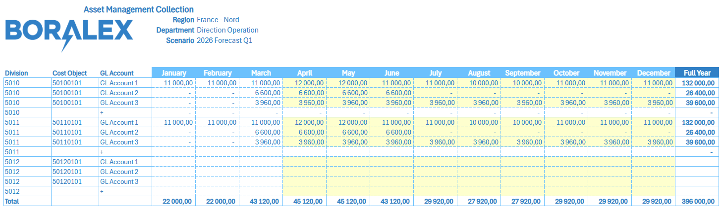

Data Integration
As part of the Asset Management Cost Planning Model, both actual and planning data are initialized from external sources. The main source identified for this process is SAP, which provides the necessary financial data.
The integration can be summarized as follows:
- SAP Actual Trial Balance
The Actual Trial Balance is read at a monthly level of detail.
Data is filtered for the relevant Divisions, Departments, and G/L Accounts associated with Asset Management costs.
- SAP Budget 2026 / Longview Budget – one time
For the initialization of forecast periods, the 2026 Budget prepared in Longview is imported via integration with SAP. Budget entries performed in LV are also imported for a complete view of the 2026 budget.
Monthly details of all Asset Management–related costs are extracted, using the same filters on Division, Department, and G/L Account applied for the Actuals.
For testing purposes, the 2025 Budget data will also be imported manually.
Further information regarding data governance, input data formats, and detailed integration logic is available in the Data Integration Document (DID) at the following location: link

Data Processing
In order to support the calculation logic related to the Asset Management Cost process, a set of Data Processing will be developed within CCH Tagetik AIH (Analytical Information Hub).
These calculations will be implemented as Data Transformation Packages (DTPs), each designed to perform a specific data preparation or initialization task required by the planning workflow.
We have identified 2 DTPs to be built within the Asset Management Cost model.

Asset Management Cost Collection Forecast initialization
This DTP is designed to initialize the Asset Management Cost data collection form by retrieving actual and forecast data from source systems and pre-populating the form with the relevant information.
More specifically, the DTP will:
- Extract Actuals from the Trial Balance loaded from SAP.
- Retrieve Budget data from SAP (from the budget done in Longview) and Longview, used as the initial reference for forecast periods.
- Starting from the second forecast cycle, the previous forecast done in Tagetik will be used as a baseline for the open forecast periods
- Filter the extracted data based on a predefined list of GL accounts, Cost Objects (by Department) and Divisions specifically related to Asset Management Cost.
- Load these values into a dataset used as a baseline for the Asset Management Cost data entry form, with monthly granularity until year-end.
This process ensures that users can start the forecast cycle with a pre-initialized form populated with both historical (actual) and reference (budget) data, aligned to the company’s chart of accounts.

Final Data Mapping and Transfer to Financial Workspace
This DTP represents the final step of the Asset Management Cost Planning process and is executed once the data collection and user adjustments have been completed, resulting in the finalized forecast for Asset Management Cost.
The main objective of this data processing is to map and enrich the data stored in the Analytical Information Hub (AIH) to make it compatible with the structures and standards required by Tagetik Financial Workspace and the related Financial Reporting environment.
Specifically, the DTP will structure the output dataset in a format fully compatible with the Financial Workspace import process, ensuring that the data can be seamlessly integrated and used within Financial Reporting and P&L Reporting templates. We do not expect major transformations and mappings to be applied, as the cost collection is already defined by G/L account, Cost Object and Division, making it compatible with the Financial Workspace reporting requirements.
This DTP ensures full alignment between the Asset Management Cost Planning output and the company’s financial reporting standards, allowing the final forecast data to be consistently consolidated and analyzed within the broader financial ecosystem of Tagetik. Consolidation of the data will occur in accordance with the standard consolidation rule established with the Boralex application.

Development Costs Planning
The Development Cost Planning Module focuses on capturing and monitoring the expenses associated with development projects across the organization. Its primary purpose is to collect and track development-related costs by Project and by Region, ensuring visibility and ownership at the appropriate planning level.
Within this process, costs are also distinguished between capitalizable and non-capitalizable amounts, based on the current Project Stage. Only non-capitalized development costs fall within the scope of this module and are planned and managed here. Conversely, capitalized costs are excluded from this model and are handled separately within the CapEx Planning Module.
Throughout this section, we refer to an Excel attachment that outlines the expected workflow structure, tasks, and data collection forms to be implemented in the Tagetik application. The attachment is available here: link

Dimensions and Granularity
Development costs will be planned at a monthly granularity, with the ability to aggregate to quarterly and annual views leveraging the standard CCH Tagetik reporting capabilities.
Key dimensions for this module include:
- Scenario
- Period
- Division
  - Region
- Cost Object
  - WBS / Project
  - Department
- Project Stage
- GL account
  - GL accounts mapped to the different WBSs to flow into the financial statements

Organizational Hierarchy, Responsibility and Workflow
The Development Cost planning process is managed through a geographically based responsibility structure. At Boralex, Development Cost Planners are assigned to specific Regions, which are built on top of the Division dimension. Each planner has a defined scope consisting of the set of development projects assigned to it, and planners are responsible for entering and maintaining all development-related cost assumptions for their allocated projects.
This organizational structure is also used to define the Submission and Approval hierarchy, not only the Data Collection layer. As a result, the same Regions, and the corresponding Country and Business Unit rollups, serve as the basis for contributor responsibilities, and multi-level approval steps within the workflow.
Below is a graphical representation of the expected organizational hierarchy supporting the process.
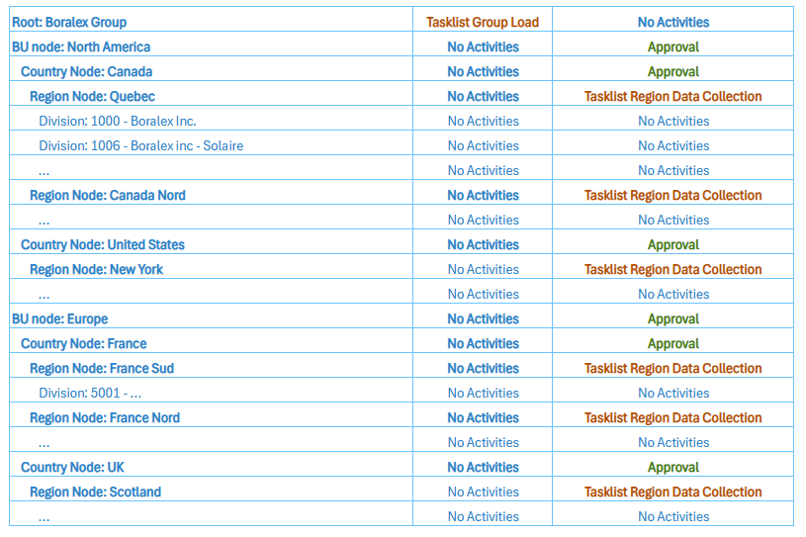
The workflow for the Development Cost Model consists of two main steps:
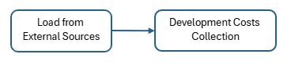
- Load from External Sources.
This phase is common across all planning models (Revenues, Asset Management Costs, Development Costs). It includes all tasks required to ingest, validate, and store external datasets into Tagetik. Activities in this phase are typically performed by the Admin role.
- Development Cost Collection.
This phase covers the full budgeting and forecasting cycle for development expenses. Data collection is executed at Region level with the Project/WBS detail, where contributors are responsible for entering and validating planned development costs for all projects assigned to their scope.
Each step includes a set of tasks to be performed by admin and contributor users. A visual representation of the workflow tasks is available below, and in the attached Excel file (available at the beginning of this section):
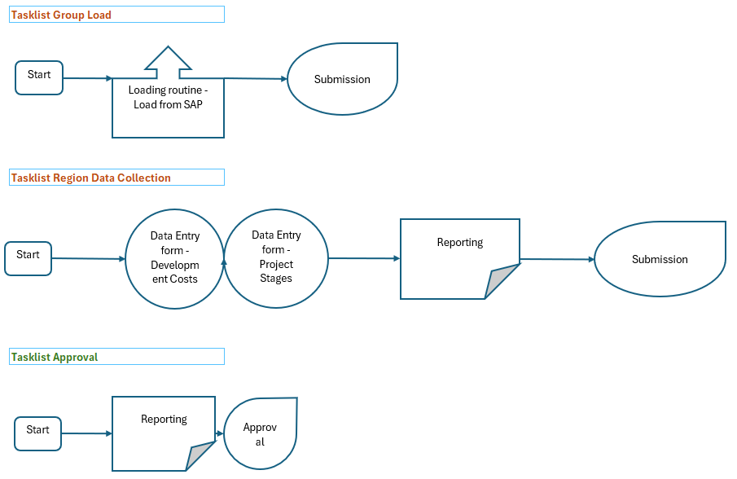

Data Collection
To support of the Development Cost planning process, two Data Entry Forms have been defined, each serving a distinct function within the model. The first form is dedicated to the collection of planned development costs, while the second focuses on the configuration of Project Stages by assigning their start and end dates. Both forms are accessible to Budget Owners operating at Region level, who will only view the projects falling within their assigned scope.

Development Costs Collection
The Development Costs Collection Form represents the primary environment in which users enter the planned development costs associated with their Region. The form is automatically filtered based on the Region inherited from the workflow, and users may further refine the scope by selecting a specific Division when applicable. Within this scope, the system displays and allows to select only the projects assigned to that Region and Division. The assignment logic is derived from the WBS structure: each WBS is tied to a Cost Center, which in turn determines the Division. Through this chain of relationships, the system identifies the project–to–Division assignment and ensures that users can enter data only on the projects under their responsibility. In addition to these structural filters, the active Forecast scenario also functions as an input parameter, since it determines the range of editable periods on the form.

The form itself follows a matrix layout, where planning periods are shown across the columns while the rows list the WBS elements grouped under their respective Cost Types. Users enter the monthly planned values directly in this matrix.
One important aspect of this form is that it does not include any reference to the Project Stage. Cost entry is performed solely at the level of project / WBS, independent of the Stage. The link between planning periods and Project Stages is managed separately through the dedicated configuration form. This design ensures that reporting on costs by Stage—both Actual and Forecast—remains fully possible, while keeping the data entry process straightforward and focused on cost structure.
A graphical representation of the data entry form is provided below, and a detailed mock-up can also be found in the Excel attachment referenced at the beginning of this section.
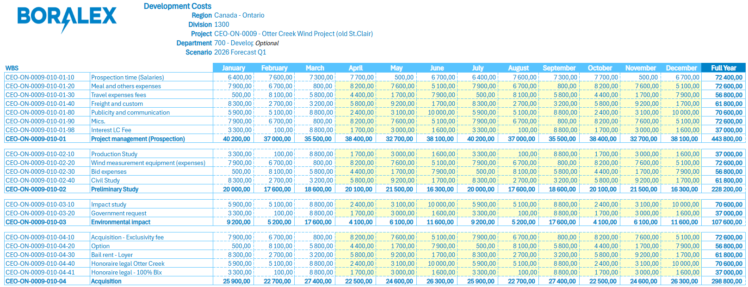

Project Stages definition
The second form is used to define the temporal placement of each Project Stage for the projects assigned to a Region. In this case, the Region is the only input parameter, and once selected, the form displays all associated projects. For each project, users can specify the expected start and end month for each Stage, following a monthly rather than daily granularity. As with the previous form, the layout is structured in a matrix format, where each project appears on a row and the various Stage date fields are available across the columns.
Actual Stage data is imported from Fabric and prepopulated on the form. Users have the ability to override this information if needed, particularly in situations where the imported data requires correction or refinement. For future periods, users simply enter the projected start and end dates of each Stage. Additional details regarding the Stage structure are provided in the section dedicated to the Project Stages analytical dimension.
A validation rule is applied at saving time: the system checks that a project is never assigned to more than one Stage within the same month, ensuring monthly uniqueness. However, the model does not enforce a chronological continuity between Stages. For business reasons, a project may legitimately move from an early Stage to a mid Stage and later return to an earlier one. The system therefore allows transitions that are not strictly sequential, as this provides the flexibility needed to reflect real-world project dynamics.
A graphical representation of the data entry form is provided below, and a detailed mock-up can also be found in the Excel attachment referenced at the beginning of this section.
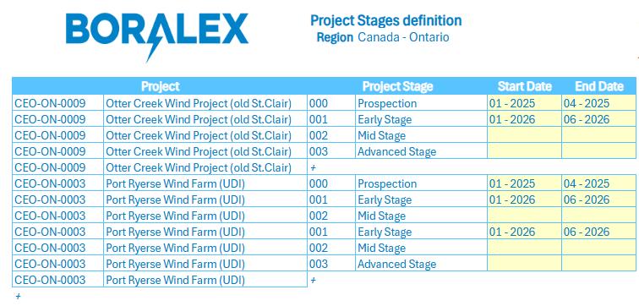

Data Integration
As part of the Development Cost Planning model, Actuals, Budget, and operational attributes are sourced from external systems. The integration landscape is summarized below.

- SAP. SAP is the primary feeding source for both financial data and project-related master data.
- Actual Costs – Trial Balance
Monthly Actuals are imported from SAP Trial Balance. Data is filtered for Development-related Division / Cost Object / GL Account combinations.
- Budget Costs
2026 Budget P&L values are imported from SAP and Longview for adjustments and eliminations, after being prepared in Longview.
The imported dataset includes monthly Budget costs for all development-related WBS elements and GL Accounts.
- Master Data – WBS & Projects
SAP provides the full WBS structure.
The integration includes the mapping between WBS elements, Cost Centers, and Projects, enabling correct assignment to Divisions and Regions within the planning model.
- Fabric. Fabric is used as a complementary source for project stage information.
- Actual Project Stages
Monthly Actual Stage assignments for each project are imported from Fabric.
These values populate the baseline for Project Stage timelines used in the planning forms.
Users may overwrite or extend Stage timelines in planning, but Actuals always originate from Fabric
Further information regarding data governance, input data formats, and detailed integration logic is available in the Data Integration Document (DID) at the following location: link

Data Processing
To support the calculation logic embedded in the Development Cost Planning Model, multiple data processing have been identified and will be developed within the CCH Tagetik Analytical Information Hub (AIH). Two activities will be implemented in the form of Data Transformation Packages (DTPs).
Each DTP is designed to address a specific data preparation, initialization, or calculation requirement needed to enable the Development Cost planning workflow. The identified data processing steps ensure that input data is properly structured, enriched, and made available to the relevant Data Entry Forms and reporting layers.
Overall, two distinct DTPs have been identified for the Development Cost model. Each of them supports a specific phase of the planning process and will be described in detail in the following subsections.

Development Cost Collection Forecast initialization
This DTP is designed to initialize the Development Cost data collection form by retrieving actual and forecast data from source systems and pre-populating the form with the relevant information.
More specifically, the DTP will:
- Extract Actuals from the Trial Balance loaded from SAP.
- Retrieve Budget data from SAP (from the budget done in Longview), used as the initial reference for forecast periods.
- Starting from the second forecast cycle, the previous forecast/budget done in Tagetik will be used as a baseline for the open forecast periods
- Filter the extracted data based on a predefined list of GL accounts, Cost Objects (by Department) and Divisions specifically related to Development Costs.
- All divisions
- All the cost objects under the 7** department
- All OPEX GL Accounts under the ‘570999 – Development’ node
- Load these values into a dataset used as a baseline for the Development Cost data entry form, with monthly granularity until year-end.
This process ensures that users can start the forecast cycle with a pre-initialized form populated with both historical (actual) and reference (budget) data, aligned to the company’s chart of accounts.

Project Phase Enrichment
The Project Phase Enrichment DTP is designed to enhance Development Cost data with project phase information once the cost collection process has been completed. After Development Costs are entered at WBS and GL Account level through the Development Cost Collection Data Entry Form, this DTP intersects the collected cost data with the Project Stage information maintained in the dedicated Project Stage Data Entry Form, either manually entered by users or loaded as part of Actuals.
Based on the project phase assignments defined for each project and period, the DTP assigns a Project Phase tag to each cost record according to the period in which the cost occurs. This enrichment ensures that each Development Cost is associated with the correct project phase over time.
By introducing this additional attribute, the system enables reporting not only by Project, WBS, or WBS aggregations, but also by Project Phase. Since project phases represent a transversal classification that cannot be directly derived from the WBS structure itself, this enrichment step is essential to support phase-based analysis, comparisons, and reporting within the Development Cost Planning Model.

Administrative Expenses Planning

Administrative Expenses in Boralex represent the corporate overhead and general administrative costs required to support the organization across all geographies and business functions. These costs typically include shared services, corporate functions, and centrally managed activities that do not belong to a specific asset or development project.
The objective of this module is to collect and plan Administrative Expenses at the appropriate Department and BU/Country level, while also enabling the allocation of a portion of these corporate costs, recorded under the Corporate Business Unit, to the operational Business Units and Countries. This ensures accurate cost attribution, enhanced transparency, and improved comparability between Actuals and Forecasts.
Throughout this section, references will be made to an attached mock-up file that illustrates the expected workflow structure, organizational hierarchy, and data collection forms to be implemented in Tagetik. The mock-up is available at the following link: link

Dimensions and Granularity
Administrative Expenses will be planned at a monthly granularity, with the ability to aggregate to quarterly and annual views leveraging the standard CCH Tagetik reporting capabilities.
Key dimensions for this module include:
- Scenario
- Period
- Division
- BU / Country
- Department / Region
- Country / Department
- Cost Object
- Department
- GL account
- Financial, to collect the cost
- Statistical, if needed as allocation drivers

Organizational Hierarchy, Responsibility and Workflow
The Administrative Expenses Planning Model relies on a responsibility structure aligned with Boralex’s organizational design, combining both geographical and functional elements. In this model, planning ownership is assigned through a hierarchy based on Business Unit, Country, and Department, ensuring that each planner has visibility and responsibility exclusively over the cost elements within their assigned scope.
Administrative Expenses planners (or budget owners) are therefore associated with a specific Business Unit and one or more Departments within a given Country. It might be possible, for a single owner, to be responsible for multiple Departments under the same organizational perimeter.
To support this structure, the Administrative Expenses model introduces a dedicated hierarchy that groups data at the Business Unit level, then at the combined Country–Department node, and finally down to the Department/Region analytical elements defined for this model. Data collection activities take place at the Country–Department level, while approval is completed at the consolidated Business Unit level.
Below is a graphical representation of the expected organizational hierarchy supporting the process.
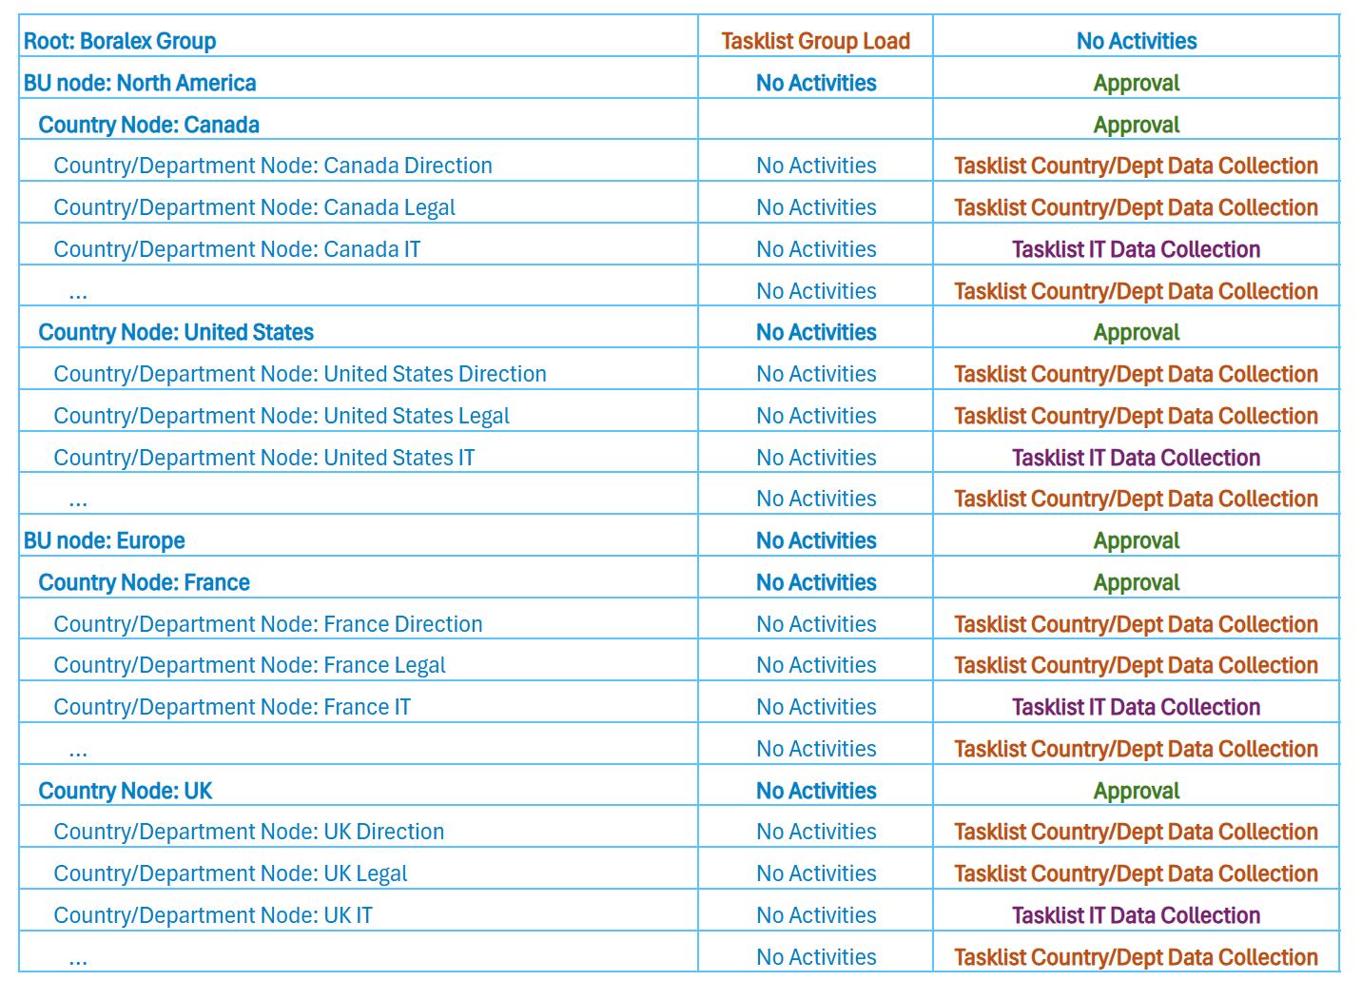
The workflow designed for the Administrative Expenses planning process is composed of two main steps:
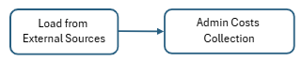
- Data Load from External Sources
This preliminary phase is common across all planning models. It includes all tasks related to the preparation of the planning cycle, such as importing Actuals, initializing Forecast periods, and loading all relevant dimensional or operational attributes. Activities in this step are typically performed by an administrator.
- Administrative Expenses Collection
This second step is executed at the Country–Department level and contains the data entry form used by budget owners to review, adjust, and submit their Administrative Expenses. Contributors are responsible for entering or modifying the planned values, while approvers validate these inputs at the Business Unit level before final submission.
Each step includes a set of tasks to be performed by admin and contributor users. A visual representation of the workflow tasks is available below, and in the attached Excel file (available at the beginning of this section):
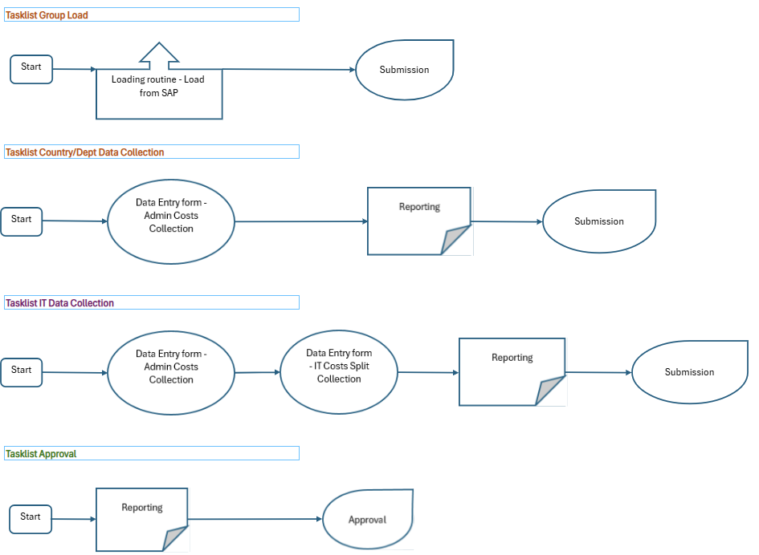

Data Collection
To support the Administrative Expenses planning process, two data entry forms have been defined. The primary form is used by all budget owners and serves as the central tool for collecting and adjusting Administrative Expense values within their assigned scope. In addition to this shared form, a second, more specialized data entry form is dedicated to the IT Department. This form is designed to manage the allocation of corporate IT costs, allowing users to define the percentage-based distribution of these expenses across the various Countries.

Administrative Expenses Collection
The Administrative Expenses Collection represents the main Data Entry Form made available as a Workflow Task at the Country / Department level. As a consequence, the input parameters of the Form are determined by the combination of Country and Department within the user’s scope, with the option to further filter the dataset by Division, if required. Another key input parameter is the Planning Scenario (e.g., 2026 Forecast Q1), inherited from the workflow as well. The selected scenario determines which columns and periods within the Form are editable and which are read-only, as they contain Actual values.
The Form follows a matrix structure, where the rows represent the combination of Division, Cost Object, and GL Account related to the Administrative Expenses, while the columns represent the relevant Actual periods and planning periods up to year-end. A dedicated Notes column is also available, allowing users to enter comments related to a specific Division–Cost Object–GL Account intersection.
The Form is pre-populated with available Actuals and prior Budget/Forecast values. Therefore, the initially visible intersections correspond to existing records. Users are, however, able to create new intersections of Division, Cost Object, and GL Account by selecting the corresponding row-level “+” actions, which allow the addition of new GL Accounts under a specific Cost Object or new Cost Objects under a specific Division.
A visual representation of the Data Entry Form is provided below.
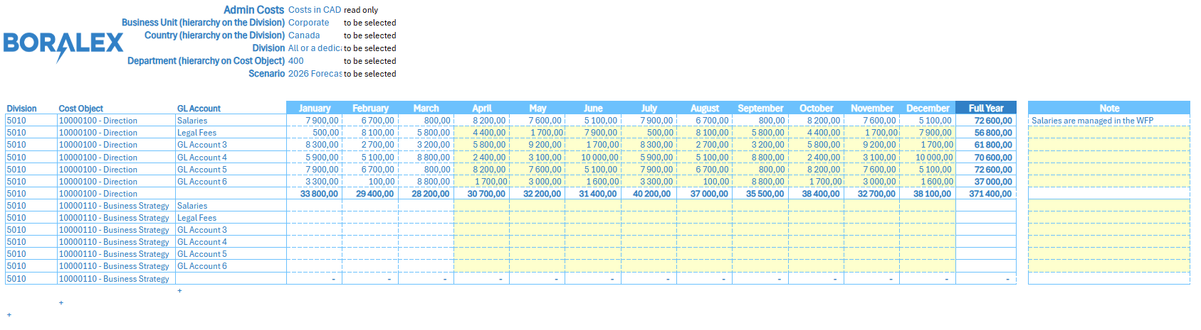

IT Cost Split Data Collection
The IT Cost Split Data Collection represents the second Data Entry Form designed to support the Administrative Expenses planning process. This form is made available exclusively within the Corporate BU workflow and is specifically tied to the IT Department. As a result, the key input parameters, Department and Corporate BU, are inherited directly from the workflow and cannot be modified by the user. The scope of this form is strictly to allocate Corporate IT costs across the target countries and cost types.
Similar to other forms, the planning scenario (e.g., 2026 Budget or Forecast Q1) is also inherited from the workflow. However, unlike the main Administrative Expenses Collection Form, this form does not include editable or locked monthly columns based on the scenario. Instead, the form refers to a single full-year IT Corporate cost amount, collected in the previous data collection form, that must be allocated.
The form is structured as a matrix, is structured as a matrix where rows represent the combination of Division (within the Corporate BU), Cost Object (belonging to the IT departments, coded 3xx), and GL Account. Each row also includes the Cost Type information - Admin, Development, or Asset Management— which is automatically derived through a predefined GL-to–Cost Type mapping and is therefore not editable by the user.
The columns represent the eight target Countries, split into:
- 4 BU-side Countries: Canada, US, France, UK
- 4 Corporate-side Countries: Canada, US, France, UK (Corporate View)
Within this matrix, users can enter allocation percentages for each row of cost across the BU and Corporate countries. If the total allocation for a given row does not reach 100%, the remaining percentage of the cost stays assigned to the originating Division.
Allocation rules differ based on Cost Type:
- Admin costs can be allocated both to BU Countries and to Corporate Countries.
- Development and Asset Management costs can only be allocated to BU Countries, and therefore cannot be reassigned to other Corporate divisions and the form will prevent editability accordingly
A visual representation of the data entry form is provided below:
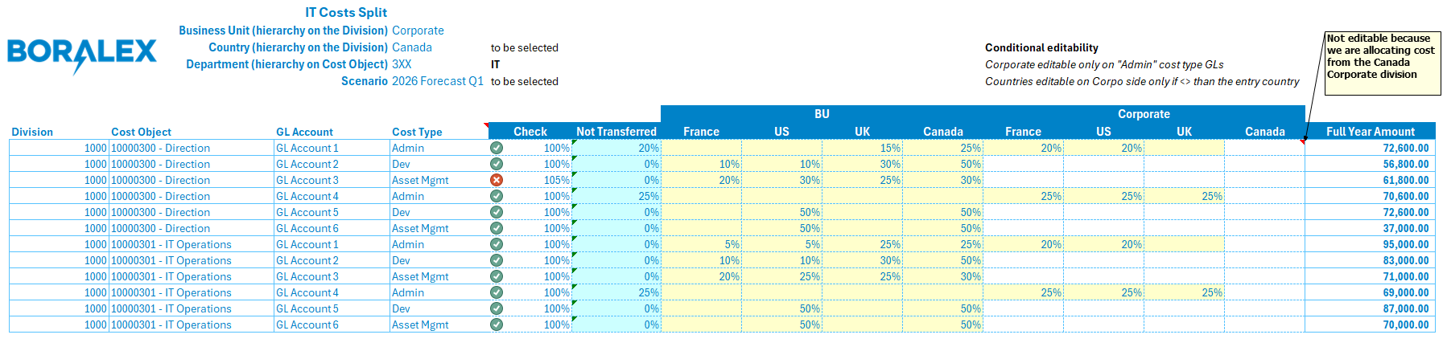

Data Integration
As part of the Administrative Expenses Planning Model, both actual and planning data are initialized from external sources. The main source identified for this process is SAP, which provides the necessary financial data.
The integration can be summarized as follows:
- SAP Actual Trial Balance
The Actual Trial Balance is read at a monthly level of detail.
Data is filtered for the relevant Divisions, Departments, and G/L Accounts associated with Administrative Expenses.
- SAP Master Data – Internal Order
The Cost Object information (Internal Orders) come from SAP and are used to populate the Cost Object dimension in Tagetik
- SAP Budget 2026 / Longview Budget – one time
For the initialization of forecast periods, the 2026 Budget prepared in Longview is imported via integration with SAP. Budget entries performed in LV are also imported for a complete view of the 2026 budget.
Monthly details of all Administrative Expenses–related costs are extracted, using the same filters on Division, Department, and G/L Account applied for the Actuals.
For testing purposes, the 2025 Budget data will also be imported manually.
Further information regarding data governance, input data formats, and detailed integration logic is available in the Data Integration Document (DID) at the following location: link

Data Processing
In order to support the calculation logic related to the Administrative Expenses process, a set of Data Processing will be developed within CCH Tagetik AIH (Analytical Information Hub).
These calculations will be implemented as Data Transformation Packages (DTPs), each designed to perform a specific data preparation or initialization task required by the planning workflow.
We have identified 2 DTPs to be built within the Administrative Expenses model.

Administrative Expenses Cost Collection Forecast initialization
This DTP is designed to initialize the Administrative Expenses data collection form by retrieving actual and forecast data from source systems and pre-populating the form with the relevant information.
More specifically, the DTP will:
- Extract Actuals from the Trial Balance loaded from SAP.
- Retrieve Budget data from SAP (from the budget done in Longview), used as the initial reference for forecast periods.
- Starting from the second forecast cycle, the previous forecast/budget done in Tagetik will be used as a baseline for the open forecast periods
- Filter the extracted data based on a predefined list of GL accounts, Cost Objects (by Department) and Divisions specifically related to Asset Management Cost.
- All divisions
- Every department, excluding 000, 425, 7**, 8** and 910
- All OPEX GL Accounts, exclude the GL starting with 4
- Load these values into a dataset used as a baseline for the Administrative Expenses data entry form, with monthly granularity until year-end.
This process ensures that users can start the forecast cycle with a pre-initialized form populated with both historical (actual) and reference (budget) data, aligned to the company’s chart of accounts.

IT Costs Allocation
This DTP is dedicated exclusively to the allocation of Corporate IT costs based on allocation drivers manually defined by the planners. The objective of this step is to take as input the full-year total IT cost, broken down by Cost Object and GL Account, and redistribute this amount across the target Divisions by Country–Cost Type intersections according to the percentages entered by users in the IT Cost Split Data Collection Form.
The allocation logic is straightforward: for each row, the total IT cost is multiplied by the corresponding allocation percentage, resulting in the allocated cost value for each target division. If the allocation percentages for a given row do not sum to 100%, the unallocated portion of the cost remains assigned to the Corporate Division under the IT Department and is not redistributed to the other divisions.
The dimensions target of the allocation are:
- Division
France BU, 5010
US BU, 3210
UK BU, 9080
Canada BU, 2061
France Corporate, 7601
US Corporate, 4031
UK Corporate, 9261
Canada Corporate, 1000
- GL Account
GL 5240190 – Asset Management Costs
GL 5740190 - Development Costs
GL 5640190 – Admin Expenses
- Cost Object
Concatenation of the Target Division and the Originating Department
This DTP ensures a controlled, transparent, and driver-based allocation of Corporate IT expenses within the planning model.

Workforce Planning
Workforce Planning focuses on forecasting headcount and personnel costs, including salaries, bonuses, and benefits. It also supports planning for new hires and allocation of labor costs to projects and cost centers.

Dimensions and Granularity
The main dimensions that require an initial configuration are:
- Payment plan: list of the patterns used to split the annual salary through the months. For instance, payment by paychecks, by working or calendar days, equally distributed to the months, payment with 13th and 14th month are examples.
- Compensation Item: Cost items that need to be calculated at the employee level. Social security, taxes, benefits (i.e., health insurance) are examples of possible compensation items.
- GL Account: Using a specific Data Entry, the user can map the compensations items to a specific GL Accounts.
- Employee Type (types of employees such as Exempt, Non-exempt, etc.). An employee type Is defined by a payment plan and a list of the compensation items to be calculated for the employees belonging to that category.
- Position: all the job titles (i.e., Director) within the company need to be listed. The position dimension might drive calculations of compensation items, therefore it’s important to assign to each title a proper code
- Employee: a pre-defined “Data source” is available to load all the employee information (i.e., employee code, name, hire date etc.).
- Chair ID (TBC): used to determine a specific code for each position in Boralex, that can help map planned new hires with new employees coming from the actual roster
The employee roster is uploaded with all the relevant employee information, and it refers to the actual roster present in Boralex.
The standard Workforce planning Module gives the possibility to manage up to two (2) additional analytical dimensions, that can be configured to tailor the Workforce planning model to meet the requirements of Boralex. The one analytical dimension that will be configured by the Tagetik team will be the Cost Object (Custom dimension 1 à analytical dimension for the WFP module).

Workflow (TBC)
[PICTURE HERE] To be added during detailed session

The information loaded In WFP module will be sensitive, so appropriate user restriction will be put in place to prevent their spread. It’s always possible to exclude the names of the employees, and to apply an average salary by entity/position to prevent sensitive information from being uploaded in the system.
The above-mentioned restrictions can be applied to the workspace and the data itself, and at the workflow level, having the workflow tasks available and visible only to a restricted set of users.
TBD -> a finalized version of the workflow will be defined during the detailed design sessions related to the WFP model.

Data Collection
All the dimensions listed above, apart from the Employee dimension and Chair ID (TBD), can be configured using a specific data collection form in Tagetik.
This data collection form is used to set up the standard workforce planning module and is used to collect all the general assumptions that will drive the salary and bonuses calculations.
For what it concerns the Employee roster and the Chair ID (TBC), there is a specific data collection form that allows to manage adjustment to the roster and plan for forecasted changes. This Data Entry is very important because it lets the user manage:
- the promotions and the transfer of a single employee between entities
- the exceptions to general assumption for specifical individuals (i.e., merit increase, bonus, ...)
- New hires, open requisitions and planned leaves
- additional fields
Through a custom data collection form, the planners will also be able to assign the cost associated with each employee to the Cost Object dimensions (specifically, Cost Centers and WBS elements), with the possibility to assign the Salary Cost to multiple elements using a split percentage by FTE #.
TBD -> Except for the standard out-of-the box data collection forms available in the Tagetik starter kit, the data collection form structures will be defined during the detailed design sessions related to the WFP model.

Data Integration
As part of the WFP model, actual and planned data will be sourced as follows:
- Dayforce: Provides employee roster, salaries, and job attributes.
- SAP: Supplies actual payroll costs by GL account.
More detailed information is available in the Data Integration document attached to this BRD.
TBD -> The specific format of each integration will be confirmed during the detailed design sessions related to the WFP model.

Data Processing
Final and complete personnel costs will be calculated based on salary, benefits, and applicable taxes, and each of these cost items will be assigned to specific GL accounts based on the mapping provided in the configuration form.
A custom data processing will be created to manage the cost split between different cost objects (cost centers and WBS elements), based on the input provided by the planners in the specific data collection form.
TBD -> the detailed data processing will be defined during the detailed design sessions related to the WFP model.

Capex Planning
Boralex is a capital-intensive company, as it requires a large amount of capital investment in physical assets, such as property, plant, and equipment, to operate and generate revenue.
CAPEX planning is therefore a strategic necessity. It enables the company to:
- Align investments with strategic goals, such as decarbonization, digitalization, and grid modernization.
- Optimize resource allocation, ensuring that capital is deployed efficiently across competing priorities.
- Manage financial risk, by forecasting cash flows, debt levels, and return on investment.
- Ensure regulatory compliance, particularly in markets where capital projects are subject to approval or cost recovery mechanisms.
- Improve transparency and accountability, through structured governance and performance tracking.
Effective CAPEX planning supports Boralex ability to deliver reliable services while adapting to evolving market conditions, technological innovation, and sustainability targets.
The CCH Tagetik Capex Planning starter kit addresses the budgeting of capital expenditures for new and existing projects. It includes planning for asset acquisition, construction, and major maintenance, as well as calculating depreciation and integrating with cash flow forecasts.

Dimensions and Granularity
The Capex Planning module will support planning at a granular level, enabling detailed analysis and reporting. The following dimensions will be used:
- Division: as part of the budget responsibility, with possible aggregation by Region and Technology
- Asset ID: Unique identifier for each asset.
- GL Account: For financial mapping and reporting.
- Asset Class: Used to define depreciation logic and exceptions.
- Fiscal Category: To segregate assets by depreciation rules and useful life.
- Investment Type: Classification into Investment or Maintenance Capex, as required for financial reporting.
- Project (WBS): The CAPEX planning starter kit allows to use up to two custom dimensions that can be leveraged to tag the different capitalized expenditures on the specific business data model.
- Funding Source: used to define the source of funding (TBD)
Granularity will allow for like-for-like comparisons between new, existing, and in-progress assets, supporting strategic decision-making and auditability.

Workflow (TBC)
[PICTURE HERE] To be added during detailed session
TBD -> a finalized version of the workflow will be defined during the detailed design sessions related to the CAPEX planning model.

Data Collection
A configuration data collection form will be made available in CCH Tagetik as part of the CAPEX planning starter kit. In this data collection form, the admin user will oversee the definition of:
- Time horizon: planning years included in the model.
- Asset model: a model used to define the output Tagetik category.
- Fiscal Categories: segregate data in different categories and, for each category, will be define:
- Asset depreciation model
- Fiscal category description
- Useful life
- Depreciation method (straight line, custom, 6-month first year, 12-month first year)
- Accounting mapping: definition, for each fiscal category, which are the item on which the depreciation should be applied and the relative GL Account
The required information, as example, can be summarized in the following table:
Asset Types | Depreciation Method | Convention | Useful Life (years) | Asset GL | Accum Depr GL | Depr Expense GL | Gain GL | Loss GL
Land
Building
Leasehold Improvements - LT
Leasehold Improvements - ST
Security Equipment
Other FFE
IT Equipment
Software

Data Integration
As part of the CAPEX planning model, actual and planned data will be sourced as follows:
- SAP: Provides actual Capex and asset master data.
- Excel: For uploading Capex plans and schedules.
More detailed information is available in the Data Integration document attached to this BRD.
TBD -> The specific format of each integration will be confirmed during the detailed design sessions related to the CAPEX planning model.

Data Processing
Depreciation on new assets will be calculated based on asset class, depreciation method and useful life, starting from the Commercial Op. Date (COD), and will then be assigned to specific GL accounts based on the mapping provided in the data collection form. This data will then flow to the financial statements, built on top of the GL account balances.
Capitalized payroll from Workforce Planning will be incorporated where applicable.
TBD -> the detailed data processing rules will be defined during the detailed design sessions related to the CAPEX planning model.

P&L Reporting (Supplemental input – Non-assigned expense planning)

Adjusted Funds From Operations (AFFO) and revolving debt calculations

AFFO
AFFO, or Adjusted Funds From Operations, is a key performance metric used to assess the recurring cash-generating ability of the business. AFFO is also referred to as discretionary cash flows considering it is a good indicator of actual cash available for distribution to investors or reinvestment in growth (through new commissioning or M&A).
AFFO is calculated in LV starting from cash flow from operations. However, for the purpose of the soft conso it we be built using EBITDA as a starting point, which is coherent with the intended approach to be formalized following IFRS 18 implementation later in 2026 (i.e. having a P&L starting point instead of a cash flow starting point). Boralex’s reporting includes AFFO along with other key metrics such as reinvestment ratios and payout ratios, as presented in their annual report and internal analyses.

The following displays the calculation such as is represented in Longview:
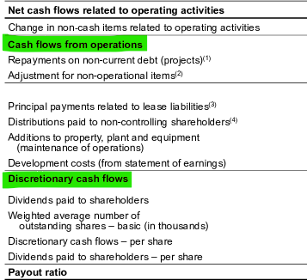
(1) Includes repayments on non-current debt (projects) and repayments to tax equity investors, and excludes VAT bridge financing, early debt repayments and repayments under the construction facility - Boralex Energy Investments portfolio. (2) Consisting mainly of acquisition and restructuring costs, adjusted for manually in the system.
(3) Excludes the principal payments related to lease liabilities for projects under development and construction.
(4) Includes distributions paid to non-controlling shareholders as well as the portion of discretionary cash flows attributable to the non-controlling shareholder of Boralex Europe Sàrl.

The following represents the AFFO calculation starting off from EBITDA:
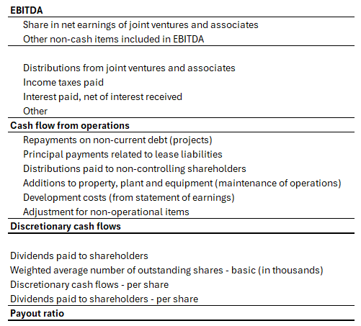

AFFO will be structured using its own hierarchy within the account dimension. A Financial Statement Template (FST) will be created to support reporting. Additional metrics—such as dividends per share or payout ratios— will be incorporated within the FST or calculated using MDX logic, depending on what offers the best balance of practicality and maintainability.
While many of the details required for AFFO will be populated during the forecasting and budgeting processes, the use of AFFO within the context of soft consolidation will require a dedicated input form to capture manual adjustments such as “Adjustment for non-operational items” and the use of MDX logic to exclude portions relating to sites under construction for the “principal payments related to lease liabilities” and the addition to property, plant and equipment..

Revolving Debt calculations
To support liquidity and cash flow planning, CCH Tagetik will include functionality to forecast revolving credit facilities. This will track borrowings, repayments, and interest charges, providing visibility into available credit and projected debt balances. These outputs will feed into the AFFO calculations described above, enhancing the accuracy of short-term funding forecasts and overall financial planning.

“Soft-Consolidation” Process
The forecast process will be configured to consolidate data in accordance with the standard consolidation rules established within Boralex’s application. As per section 13.1, this includes automated handling of full consolidation for subsidiaries, Minority Interests (Non-controlling Interests), Joint Ventures and associates accounted for under the equity method, and consolidation journals for structural adjustments. A separate proportional consolidation process will be available to support internal reporting requirements, enabling interests in joint ventures and associates to be reflected proportionally across financial statements. Intercompany eliminations will be systematically applied to remove intra-group transactions and ensure accurate consolidated results. The process will also incorporate currency translation for foreign entities using appropriate exchange rates, alignment of accounting policies across all entities—including reconciliation between IFRS and US GAAP where applicable—and support for multi-dimensional reporting across Legal, Technology, Geographical, and Business Unit hierarchies. It is important to note that balance sheet reporting and eliminations are not included within the “soft consolidation” process; these will be addressed exclusively through the formal consolidation framework, which applies to actual data only.

“Soft-Consolidation” Process workflow
Maintenance – from Consolidator (004- Business Unit node)
The process of soft consolidation is completed via 3 workflows. Maintenance: Feeds Actual data into the Soft Consolidation scenario via a DTP (Data Transfer Protocol). This process copies balances from source scenarios into the scenarios of the selected process.

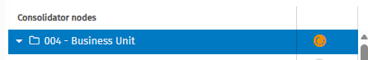
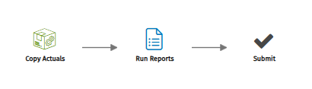

Monthly Load – from Contributor (any node or division)
The monthly load workflow gathers data from the Forecast reporting cube. Subsequent Data entry is required to capture non forecasted accounts. Users have the ability to enter manual journal entries as well as to run reports and validate intercompany prior to submitting.
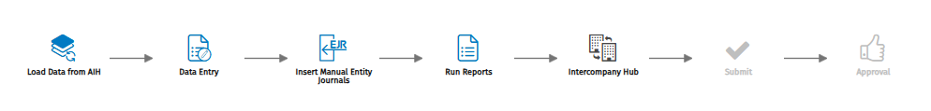

Consolidation – from Consolidator (any node)
Consolidation of forecast data is then completed via the consolidator menu in the consolidation workflow.
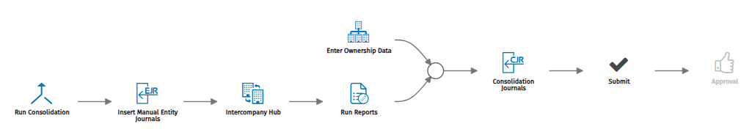

Workflow
Workflow will be configured for consolidation functionality in Actual, Budget, and Forecasting processes. Contributor and Consolidation tasks will be split into different Steps. It will be defined during the detailed requirements sessions if multiple workflows are required for the Divisions or if a single workflow can be used consistently for each.
Below is a sample Workflow Steps diagram indicating what is possible. The actual workflow will be configured during a two (2) hour working session held during requirements gathering sessions dedicated to workflow configuration.
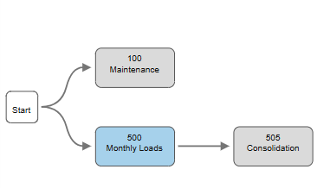
Below is an example of Entity Workflow tasks. Approval Steps may be added as needed. The actual task definitions will be configured during the Workflow configuration session mentioned above.
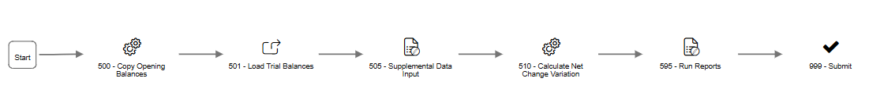
Below is an example of Consolidation Workflow tasks. Steps related to approvals may be added as needed. The actual task definitions will be configured during the Workflow configuration session mentioned above.
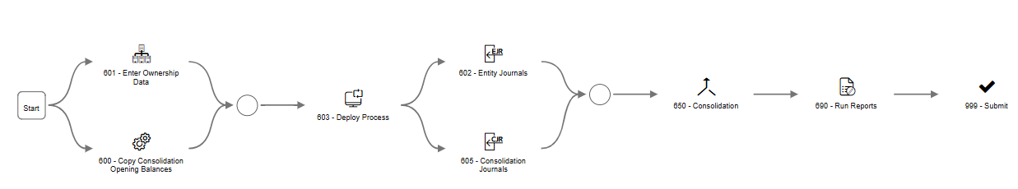

Ownership Structure Register
The Ownership Structure Register is where the owner/owned entities relationships are defined including the financial investment, the equity, and the spot rate at transaction date.
All the relationships declared within the ownership structure will provide CCH Tagetik the drivers for automatically calculating the Financial Investment eliminations. The Ownership percentage, the value of the investment and the net equity of the owned entities will be combined with the consolidation methods declared within the entity metadata structure. With the above information CCH Tagetik will be able to calculate the automatic adjustments required to eliminate investments in subsidiaries and associated Equity, NCI, and proportional components.
The Ownership structure is based at the entity level; thus, the financial investment/equity eliminations are to be provided by Boralex at the entity level. Additional override (historical) FX rates are also to be provided by Boralex.

Basic Consolidation Configurations

OSR Accounts Configuration
The accounts and variations required for OSR configuration are derived from the Equity section of the balance sheet as well as the investments in subsidiaries’ accounts and variations. The configuration will be completed as part of the foundation setup of the application. Boralex must provide detailed elimination entries - including any currency override rates for historical valuations.
Note: This is not required for the early phases of this project. The detailed journals entries will be required when full consolidation (Phase 4) begins. Currently, only ownership % will be required in the OSR.

Intercompany Eliminations
Intercompany (I/C) transactions that impact Trial Balances and consolidated financials. As with standard intercompany processing protocols, the CCH Tagetik application will be configured to perform automatic eliminations of intercompany amounts during the consolidation process.
- In-SCOPE Intercompany Profit elimination on Transfer of PPE. TBD

IC Cockpits
The I/C cockpit is an out-of-the-box functionality that allows monitoring I/C transactions. One cockpit will be configured for use with each process.

Conversion
Generic currency conversion rules will be configured for Currency conversion and applied to all processes as needed.
Note:
CCH Tagetik uses divide to convert from local currency to consolidation currency. Therefore, rates must be provided in accordance with the way the system calculates.

Non-controlling Interest [NCI]
Non-controlling interest (NCI)—also known as minority interest—represents the portion of equity ownership in a subsidiary not attributable to the parent company. In other words, it's the share of net assets and net income of a subsidiary that belongs to shareholders other than the parent.
In CCH Tagetik, line-by-Line method calculations are used for consolidation % less than 100% but more than 50%. According to this method, CCH Tagetik automatically calculates the NCI values based on the ownership % and post NCI entries to the Equity and NCI accounts as per the configuration. NCI consolidation will be used for IFRS and USGAAP reporting related to ’s legal reporting requirements. The elimination of NCI will be stored in the NCI Category (Category code TBD), and a Category hierarchy will be built to include these amounts for reporting purposes.
Note: NCI will be calculated on the NET_RESULTS for all entities assigned ownership %’s <100% but greater than 50% – which differs from the current method being used in Longview.

Equity Pickup
In IFRS, Equity Pickup (also known as the equity method of accounting) is used when an investor has significant influence over an investee but does not control it. The percentage thresholds commonly used to determine the appropriate accounting treatment are:
Key IFRS Thresholds for Equity Pickup:
Ownership % | Accounting Method | Description
< 20% | Fair Value or Cost | Typically, no significant influence; investment is treated as a financial asset.
20% – 50% | Equity Method | Presumed significant influence; equity pickup applies.
> 50% | Consolidation | Control is presumed; full consolidation of financials.
Important Notes:
- Significant influence can exist even below 20% if there are other indicators (e.g., board representation, participation in policy decisions).
- Conversely, lack of influence can be argued even above 20% if the investor is demonstrably passive.
- Under the equity method, the investor recognizes its share of the investee’s net income, other comprehensive income, and dividends received reduce the carrying amount of the investment.
Consolidation Presentation of Equity Pickup (Joint Ventures and Associates Investment)
✅ Balance Sheet (Statement of Financial Position):
The investment in the associate is shown as a single line item:
  - Non-current asset: Investment in Joint Ventures and Associates
✅ Income Statement (Statement of Profit or Loss):
- The investor’s share of the associate’s profit is shown as a single line item:
  - Share of profit from Joint Ventures and Associates: Share of profit from Joint Ventures and associates
❌ No Line-by-Line Consolidation:
- Unlike subsidiaries, assets, liabilities, revenues, and expenses of the associate are not consolidated line-by-line.
- Only the investor’s share of net income and dividends received affect the investor’s financials.
📘 Example Summary in Consolidated Financials:
Section | Line Item
Assets | Investment in Joint Ventures and Associates
Income Statement | Share of Profit from Joint Ventures and Associates
Cash Flow | Dividends Received from Joint Ventures and Associates

Proportional Consolidation
Proportional consolidation is an accounting method used to report the financial results of a joint venture or jointly controlled entity. Under this method, a company includes its proportionate share of the assets, liabilities, revenues, and expenses of the joint venture in its own financial statements.
🔍 Key Features of Proportional Consolidation:
- Ownership Share Reflected:
  - Only the percentage of ownership (e.g., 50%) is consolidated.
  - For example, if Company A owns 40% of a joint venture, it includes 40% of the JV’s assets, liabilities, revenues, and expenses in its own financials.
- Line-by-Line Consolidation:
  - The investor’s share of each individual line item (e.g., cash, inventory, sales, cost of goods sold) is included in the investor’s financial statements.
  - This contrasts with the equity method, where only the net investment and share of net income are shown.
- No Minority Interest:
  - Since only the investor’s share is included, there’s no need to account for non-controlling interests.
- Used in Joint Control Situations:
  - Typically applied when two or more parties jointly control an entity (e.g., a 50/50 joint venture).
📌 Important Notes:
- IFRS: Proportional consolidation was allowed under IAS 31, but IFRS 11 (effective since 2013) replaced it with the equity method for joint ventures.
- US GAAP: Generally, does not allow proportional consolidation for joint ventures; the equity method is used instead.
Proportional consolidation will be used for internal management reporting related to Boralex’s “Combined” statements requirement. The elimination of proportionality will be stored in the Proportional Category (Category code TBD), and a Category hierarchy will be built to include these amounts for reporting purposes.
Note: In certain cases, an entity may be classified as a joint venture under IFRS and therefore accounted for using the equity method at the consolidated level; however, from a statutory perspective, the consolidation would lead to the recognition of a non-controlling interest (NCI) for one of the three partners.

Carry forward logic
Carry forward logic will be configured for Retained Earnings (RE) and NCI.

Diagnostic
Generic diagnostic rules will be configured to run during entity data processing and consolidation data processing.

KPI’s and Custom Calculations Logic
Some statistical and/or KPI accounts will require calculations for reporting purposes. Should the data need to be stored back to the system MDX logic will be required.

Historical Data and Journal Entries

History prior to Rebuild Periods
Historical data prior to 2025 is out of scope for this project and will not be loaded at this time. This will be revisited during the Consolidation of Actual phase of the project – scheduled for 2027.
Historical Data Import – Longview
Scope: Historical data will be imported from Longview for the following:
- Local Currency (LC) level by Division
- Consolidated level – currency and divisional structure requirements TBD
- Journal Entries – All local and Consolidated Entries by Division and Historical Adjustments/Elimination entities.
Note: Adjustments will be loaded as values in categories developed specifically for historical data purposes. Consolidated data will be validated to Longview via data validation reports to ensure accuracy.
Purpose:
- To support reporting and comparative analysis
- Ensures continuity and consistency in financial disclosures
Forward-Looking Use:
- Data will be maintained and updated on a go-forward basis
- Enables ongoing performance tracking and variance analysis

Journal Entries

Journals from Longview
Journal entries will be loaded from Longview to ensure consistency across both environments in the short term. Journals from Longview will be loaded to individual categories to match the Longview data views. Note: These journals will only relate to adjustments to divisional data in the Budget and Forecast scenarios. Any automatic eliminations related to Intercompany, NCI, Equity Method, etc. will be created by the system during the consolidation data processing.

Going forward process
Once full financial close and consolidation is transitioned to CCH Tagetik, journal entries will be performed directly in the new solution.
CCH Tagetik journal entries are stored in the Category dimension. This dimension allows data, especially journals, to be classified and segmented. It also allows you to keep track of the way in which data are generated. In fact, classifying the data into different categories allows you to:
- Treat them differently during processing
- View them separately in the forms and reports

Data Integration Requirements/Data Sources Overview
Please see attached the Data integration Document (DID) containing all details related to the data integrations that will be implemented to support CPM processes in Tagetik.
Data is typically loaded to Tagetik on a Year-to-date (YTD) basis. It is expected that all SAP flat files will contain YTD information. Additional details to be included in the DID. Also actuals will be loaded on daily basis to compare with Budget & Forecast.

Reporting

Financial Statements Templates (FST’s)
A financial statement template (FST) is a structure used to aggregate accounts or custom accounts/dimensions that can represent financial statements, KPIs and other indices for reporting. A financial statement template can be added to a matrix in its entirety or in part as a filter to be able to design its structure more quickly and efficiently. For every financial statement template, relationships can be defined on the basis of the account dimension, the custom dimension, the account/custom dimension pair or the account/control type pair.
Relationships can be defined synthetically by specifying, in the definition, the individual accounts (or dimensional elements) and/or hierarchy nodes that must be added to or removed from the various FST items: the effective resulting relationships are identified by applying the specifications according to the defined order.
FST’s will be built to standardize the look and feel of Boralex’s report rows.

Reports
Boralex has a large number of reporting requirements. To support this, the Boralex project team is expected to complete the CCH Tagetik Report Writing Training available on the Tagetik Learning Hub, enabling them to independently build the reports they need.
As part of the engagement, RCGT will develop reports and will provide coaching to the Boralex team during the development of these reports to support their ability to build additional ones. Users will have the ability to use the Tagetik Excel Add in to run reports.
RCGT will build the following 5 reports:
- AFFO build up
- Waterfall of revenues
- Capex & debt issuance
- Crédit rotatif
- P&L with ability to go to LL
A complete list of required reports, including mock-ups, should be provided prior to the start of the build phase.

Security and Auditability
Tagetik uses two different security layers: Application Security and User Rights (i.e., data level security).
Tagetik team will support the configuration of Roles and User Rights settings through a dedicated training / working session (up to 16 hours).

Application Security

Roles
Application-level security is governed by the User Roles that are set up within Tagetik. By the means of the User Role Tagetik checks what a user can do within the system, namely if he is authorized to access:
- A specific Tagetik database (e.g., Dev1, Dev2)
- A certain menu or utility
In Tagetik, there is a set of pre-defined standard roles. Please refer to Appendix 1 for a list of these roles and their descriptions. These standard roles are system roles that cannot be changed or deleted. However, new roles can be created based on these pre-defined roles. These roles determine the users’ application-level security within Tagetik.
Based on discussion during the JAD sessions, Boralex may need to leverage only standard roles within CCH Tagetik. However, custom roles can be configured depending on Audit compliance requirements. This will be determined during the detailed design sessions related to security of each model.

Reference Users
Reference users act as groups to provide access to the various elements in the User rights module. Reference users will be created to support the User rights definition during the implementation phase.
It should be noted that user rights in CCH Tagetik are cumulative. Meaning once a user has been granted access to a particular data element it cannot be taken away using an additional reference user. In this case, it is recommended to create several reference users that grant rights to the various, hierarchies, nodes, and data elements. This modular approach allows the greatest flexibility when assigning rights to users, as a user may be assigned multiple reference users to achieve the desired level of security.

User Rights
In addition to application-level security Tagetik allows for data-level restrictions to ensure that sensitive data is not accessed by unauthorized users. This type of restriction is governed by Tagetik User Rights. The User Right is the security layer which Tagetik uses to check whether the user is authorized to access/insert/modify data in a specific data-point.
User Rights can be defined at the dimensional element/node level. For example, user rights can be configured such that certain users can access only specific Departments, while having no visibility into others. On the other hand, a different group of users may fully control (read/edit data) some departments and have access in "read only" mode for others.
User Rights can also be defined at the form-level where end-users can be limited from accessing specific Date Entry and Reporting Forms.
Setup of User Rights requires additional setups and configuration to be created in Tagetik by using Reference Users.
Based on the requirements gathered during the JAD sessions, the Tagetik application user restriction will be based upon the following Tagetik components:
- Entity/Workflow Dimension – to prevent user to edit/see data outside of their control and to perform process tasks which they are not responsible for.
- Forms (i.e., Data Entry and Reports) – to prevent users from running reports or data entry templates that they are not authorized to use.
- Other data processing – users can be limited in the usage of data processing such as ETLs, MDXs or others.
- Report writers and viewers – to allow specific users to create reports and have view only access to the data.

Audit
Audit facilitates checking and controls. It allows the tracking of all operations on CCH Tagetik, based on logins, and records who did what, when, where and for what reason.
Traceability
Operations can be traced by:
- Entering the following information for the data and metadata of each table:
- Origin: part of the application that generated the data (see Welcome to theCCH Tagetik Help center)
- Userupd: user who performed the operation
- Dateupd: date on which the user performed the operation
- Control engine for data and relative changes
- Query Analyzer function

Open points
Several discussion items raised during the requirements gathering sessions remain open and unresolved, pending further feedback, confirmation, or additional information from relevant stakeholders. These items are being tracked and will require clarification to determine their potential inclusion in the current or future phases of the project.
A summary of the outstanding items is provided below for reference and follow-up:
<!!> Open Point# 1: The list of Categories to be used is still pending
Note: Category codes and Grouping Codes are subject to change based on feedback from Boralex
<!!> Open Point# 2: Decision on streamlining balance sheet accounts
<!!> Open Point# 3: To support the reporting requirements that are currently represented in Longview, Boralex will use financial statement templates (FSTs), that are a standard Tagetik functionality. Tagetik team can configure FSTs during the project implementation phase (according to the current scope of the SOW) and will provide Boralex with the necessary knowledge to start defining FSTs autonomously. Boralex need to take a decision on which FST’s RCGT will build.
<!!> Open Point# 4: Boralex to provide Variation Groupings along with the specific Normal accounts the groupings will apply.
<!!> Open Point# 5: Boralex must provide an updated sample data file from SAP to enable completion of the DID documentation.
<!!> Open Point# 7: In-SCOPE Intercompany Profit elimination on Transfer of PPE. TBD

Requirements Traceability Matrix
During the requirements gathering sessions, several items were identified and discussed that are now considered critical to the success of the project. These items have been defined as final deliverables.
If any out-of-scope items are later brought into scope, it is important to note that this will directly affect the previously provided estimates—impacting timelines, resource allocation, and overall project cost.
Please click on the link: Requirements for a complete list of project requirements and deliverables.

Acceptance of Business Requirements Document

Acceptance of BRD

Boralex | Raymond Chabot Grant Thornton
Date | Date
Name (printed) | Name (printed)
 | DAVID MAYRAND
Title | Title
 | Partner, Management consulting
Signature | Signature

---------------------------------------------------This document is subject to change--------------------------------

Appendix

Appendix 1

Application Security Matrix
Role | Description
$ALL | A user provided with this role can access any utility.  This user must have an Administrator license.
$ADMINISTRATOR | A user with this role gets advantages as unique administrator of the application database and can:  - define the basic and user rights tables  - parameterize the rules (Cash Flow Planning, Allocation and Closing, consolidation, ETL).  - configure the data entry and the reporting by managing the data entry / output forms layout and the reporting schemes.  - parameterize the database process.  - perform operations on data preliminary to data entry by other users as changes insertions and tax rates  A user with this role CANNOT perform the data entry of original data.  This user must have an Administrator license.
$AUDIT | A user provided with this role can visualize all data and all the tables, but he cannot modify them.  This user must have a Power User or Administrator license.
$CONSOLIDATOR | A user provided with this role has the advantages of a Consolidator and can:  - perform consolidation data entries: consolidation adjustments, consolidation data processing (proportional calculation, minorities generation, conversion, GPN, equity entities treatment).  - perform the Legal Structures data entry.  - manage intercompany.  - monitor the single contributor's activity.  This user must have a Power User or Administrator license.
$SYSADMIN | A user with this role has advantages as system administrator and operates only on the Repository. He can:  - create custom roles.  - create users and define their roles.  - manage the user’s visibility on the application databases.  - manage the data processing run mode and their scheduling.  - manage the database import and export.  - manage the logs  This user must have an Administrator license.
$USER | A user provided with this role has the advantages of a Contributor. He can:  - perform the amounts and pre-consolidation adjustments data entry.  - perform the data entry from form.  - perform the IC entries data entry.  - perform the data processing of a single entity.  - perform the diagnostic per each entity.  - Submit data.  All these activities are limited to the entities whose user has rights  This user must have a Power User license.
$DEREPORT | A user with this role can run Reports and Data Entry Forms. This role can also run data processing that is included in a Data Entry Form or configured in a Process Workflow.  This role contains all functionalities available for users with the Data Entry & Reporting license type and must have that license type or higher.
$ANALYTICS | A user with this role can see the reports published on Tagetik Analytics Web portal according to his rights but he cannot access the web interface of the application  This user must have a Tagetik Analytics license.
$MDMADMIN | A user with this role can use the MDM (Master Data Management) tool for Data and Metadata migration.  This user must have an Administrator license.
$MDMUSER | A user provided with this role can change the Tagetik elements but not the data.  This user must have a Power User or Administrator license.

- This page was intentionally left blank -

